Machine design MMF092

Department of industrial and material science

Group 1

2021 - Study period 2





**Table of content**

**Chapter 1. Introduction 1**

*1.1* *Background 1*

*1.2* *Goal 1*

*1.3* *Method 1*

*1.4* *Delimitation 1*

**Chapter 2: Reverse engineering 2**

*2.1 Black box 2*

*2.2 Function structure of hypothetical product 2*

*2.3 Bill of material 3*

*2.4 Exploded view existing product 4*

*2.5 Component based DSM 4*

*2.6 Ishikawa diagrams 5*

*2.7 Requirement specification for existing product 8*

*2.8 Functional structure - Existing product 8*

*2.9 LCA analysis – Existing product 8*

*2.10 DFA – Existing product 11*

**Chapter 3: Redesign 12**

*3.1 Functional structure – New product 12*

*3.2 Scenario description for two market segments 12*

3.2.1 Families 12

3.2.2 Upper class 13

*3.3 Mood boards 13*

3.3.1 Mood board for families 13

3.3.2 Mood board for the upper class 14

*3.4 Design evaluation of price segments 14*

*3.5 Differentiation plan 15*

*3.6 Requirement specification – New product 15*

*3.7 Concept generation 15*

*3.8 Compilation drawing & order of assembly 17*

*3.9 Drawing of the three most important parts 18*

**Chapter 4: Material selection 20**

*4.1 Handle: Families 20*

*4.2 Casing: families 22*

*4.3 Handle: Upper class 23*

*4.4 Heating plate 23*

*4.5 Sliding elements 24*

*4.6 Casing for the upper class 25*

**Chapter 5: Modelling & Analysis 28**

*5.1 RD&T Analysis 28*

5.1.1 Stability analysis for part 28

5.1.2 Stability analysis for measure 28

5.1.3 Variation analysis 29

5.1.4 Contribution analysis 29

*5.2 LCA – New product 33*

*5.3 DFA – New product 34*

*5.4 FMEA – New product 35*

*5.5 Design FMEA – New product 35*

*5.6 Manufacturing cost 35*

**Chapter 6: Verification 36**

*6.1 Families segment 36*

*6.2 Upper class segment 37*

**Chapter 7: Conclusion 37**

**Chapter 8: Methodology 38**

***Appendices* 39**

*Appendix A: Bill of material for existing product 39*

*Appendix B: Requirement specification for existing product 40*

*Appendix C: LCA – Existing product 42*

*Appendix D: Requirement specification for both market segments 43*

*Appendix E: Morphologic matrix 43*

*Appendix F: Kesselring matrix 43*

*Appendix G: FMEA – New product 45*

*Appendix H: Design FMEA – New product 46*

# Chapter 1. Introduction

## Background

This project was done for the course MMF092 Machine Design at Chalmers university of technology together with five students. The purpose of this project was to develop a coffee machine based on an existing product that was given as a base model to be evaluated upon. The base model was evaluated and disassembled to study the materials and functions of each component.

The new product should outperform the base model for two selected market segments in an already saturated market. This course covers topics such as modular and integrated design, how they differ and their advantages and disadvantages. Another important aspect in this project is considering the environmental impact through making design changes and selecting materials.

## Goal

The goal of the project is to develop a new product based on modular design that outperforms the existing product for two market segments. It should have a clear improvement in performance and a focus on having a friendly environmental profile. The two final products will share common components and have variation in some specific components so that it suits both marketing needs. The cost of the final product will be suited for the two selected segments.

## Method

To develop a product there are many analyses needed and in this project, there are many different methods to analyze the product's characteristics. Design structures matrices of the component-component relationship are needed to study which modules have many components that rely on each other and to see the interface between them. Another important study is the cause and effects analysis (Ishikawa diagram) to analyze different characteristics in the coffee machine that could affect different factors. Those different factors are for example, modularization, performance and the environment. Furthermore, to improve other phases of the product many other analyses are made, e.g. LCA, RD&T for three important parts of the product and also an FMEA analysis.

## Delimitation

For this project there will be no focusing on electrical components and its functionalities since it is beyond the purpose of this course. It is not required that this product functions in real life but the design evaluation should be kept realistic. No physical product of the final design is expected.

# Chapter 2: Reverse engineering

## 2.1 Black box

A black box model describes a system where the internal workings are unknown. This is a method used to understand the functional structure of a system. To understand the process of brewing a coffee all the outputs were first imagined. Looking at a typical coffee machine, three different outputs were identified: Coffee brew that has been filtered, coffee waste, and waste heat.

The next step was to imagine what type of inputs are required to produce the output. The ones identified were energy to run the system, water, coffee, filter, and user input. The black box is presented in figure 2.1 below.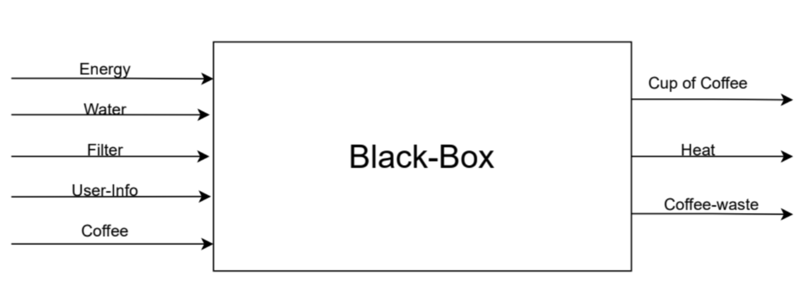



## 2.2 Function structure of hypothetical product

After the black box was made the next step was to do a function structure of a hypothetical coffee maker and imagine what type of functions it needs to get the same outputs in the black box with the inputs. The function structure is shown in figure 2.2. There is a level of bias since the internal workings of a coffee maker was in general already known beforehand which aided in identifying the functions.

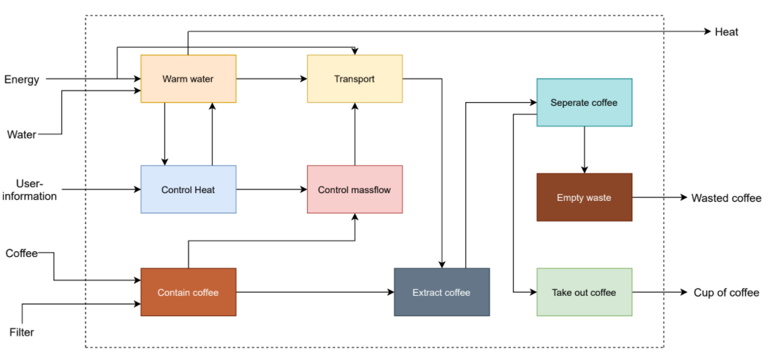

## 2.3 Bill of material

Once the existing product function structure was identified, the disassembly of an actual machine allows for a more comprehensive understanding of how design choices relate to the functionalities.

For the first laboratory, a complete coffee maker was given to be disassembled. The product can be described as compact and inexpensive relative to its competitors. After disassembly, a total of 33 components were identified and 50 parts in total were documented using pictures and named by an alphabetical letter. Some components were grouped, like electrical wires since this does not relate to the project and is not of interest. After that, each component was weighted and the material was identified generally with labels such as “plastic”, “glass” or “aluminum”. Once that was established the manufacturing process for all the components was also identified. The complete BOM for the existing coffee maker can be seen in Appendix A.

## 2.4 Exploded view existing product

Below is an exploded view of most of the components of the existing coffee machine.

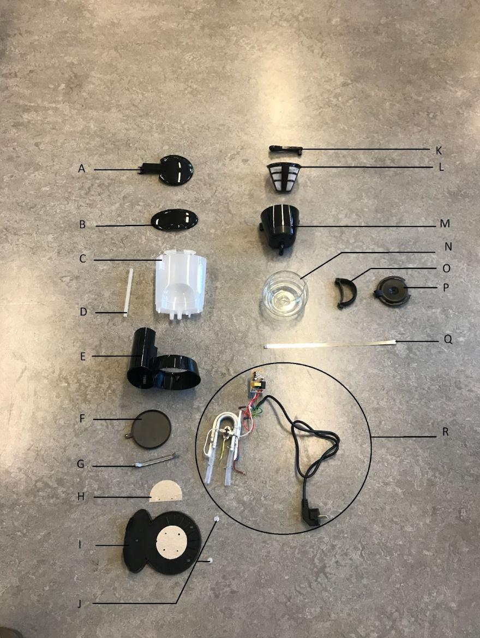

*Figure 2.3 Exploded view of existing product*

## 2.5 Component based DSM

Establishing a DSM table will allow for module definition, thus forming a base for differentiation. To make the DSM table and divide the components into modules, requires disassembling the existing coffee machine and noticing how the components were assembled. Since the coffee machine was built of many components some prioritization was needed. Due to the compact design, the DSM table will not be orderly because there is a physical relation between most of the components even if they don't have any type of functional connection. After the table has been created, The Matlab software has been used to make it easier to create the modules.

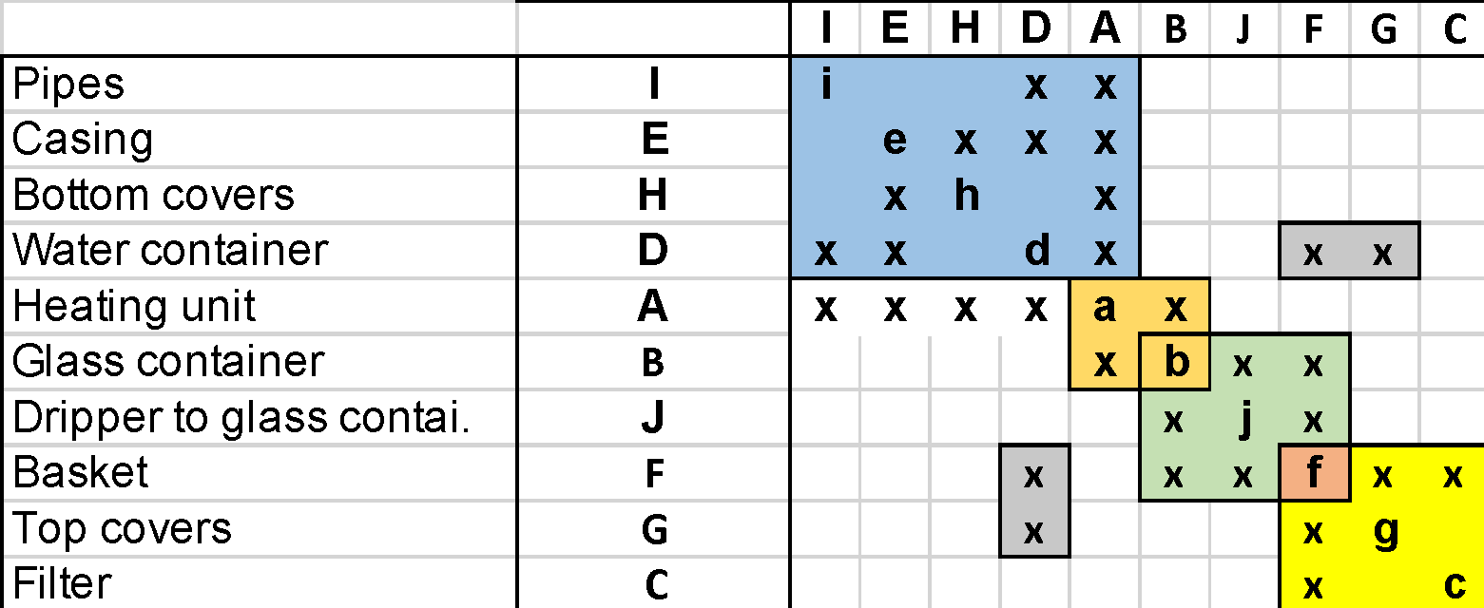

*Figure 2.4 DSM for existing product*

* The blue module represents the casing and water holding parts, such as pipes.
* The orange one represents the need of being the container close to the heating element to hold the coffee to the right temperature.
* The green module shows the extracting process from coffee grind to coffee.
* The yellow one represents coffee grind holding parts.
* The last and the smallest module in the table explains itself. Just the coffee grind holder and it’s cover.

## 2.6 Ishikawa diagrams

In this section, five Ishikawa diagrams were analyzed to find the causes and effects of different aspects. With the following diagrams, different factors and causes were identified to understand what can lead to, for example, quality defects in the coffee machine. The first diagram (figure 2.5) is about the environment and how the product can affect it. The manufacturing process is a factor that we can’t prevent in this situation and that's why emissions are a cause that has an impact. Besides the emissions, we also have to consider the material selection, because of the recycling aspect. Is the material recyclable or not?

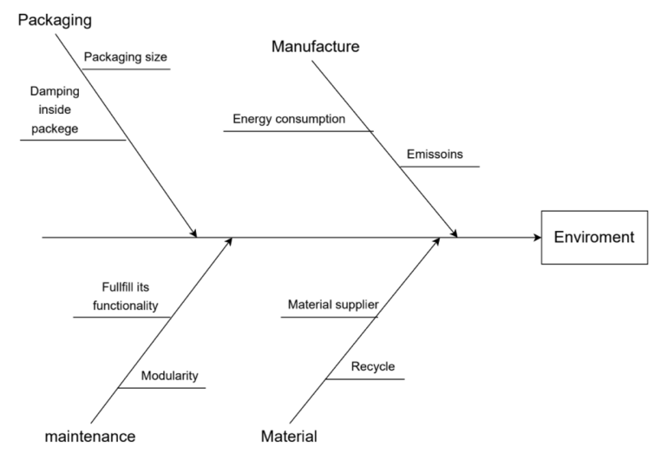

*Figure 2.5 Ishikawa for environment*

The second Ishikawa diagram (figure 2.6) is about manufacturing costs. There are many factors we could take into account in the diagram, but we chose to be more general in the Ishikawa’s. For example, machine costs, tool costs, and other equipment are factors that can affect manufacturing costs. How precise is the product going to be? This is an important factor because more precision requires more time, which leads to higher costs for the company. How many products is the company going to produce in a month or a year and what type of materials are going to be used in the manufacturing process? Besides the machining and volume, we also have to think about how many employees are working in the factory.

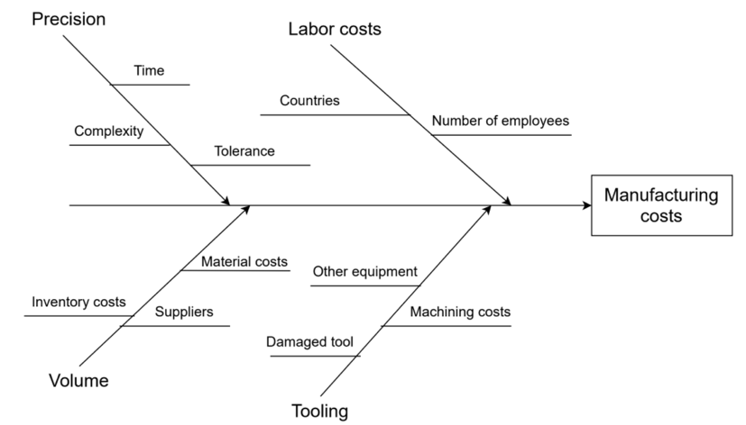

*Figure 2.6 Ishikawa for manufacturing costs*

The third Ishikawa (figure 2.7) is about the image of the product and what can affect this image. This is much like the customer's satisfaction with the product and that's why “people” is a factor in this situation. A stressed person that wants a coffee real fast may be a little bit disappointed if the coffee-water ratio isn’t perfect. This problem could not just be the coffee machine, but also could be that the person does not know how the machine works. Other details that could affect the image of the product are the components of the machine e.g. filter and coffee grinder. The life cycle of the machine is also an important factor because it’s the key to developing different plans for marketing and increasing product usage.

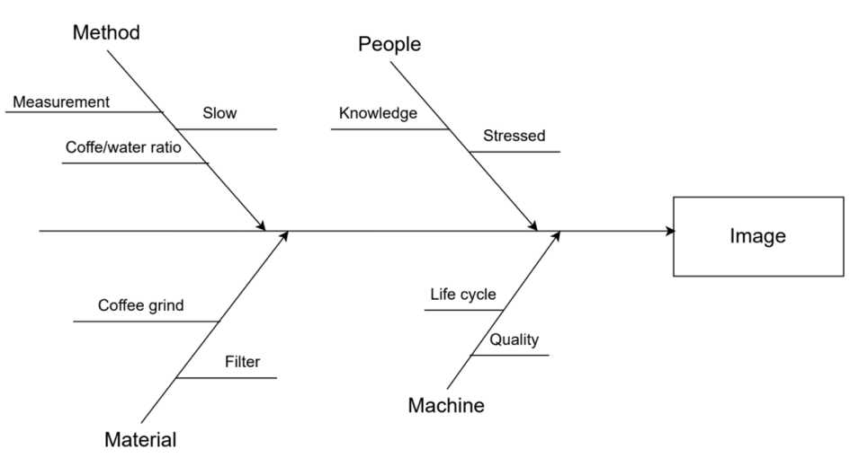

*Figure 2.7 Ishikawa for image*

Modularity is affected by different areas, manufacture, customer needs, design, and quality. Not having a defined process order will lead to manufacturing problems that affect modularity and makes it harder to achieve. It may affect the functionality and without a functional product it’s hard to reach modularity. Having a “carry over” would also mean old design and also old design problems that are required for the new product which also affects customer needs. Quality is also very important for modularity because not having a high quality might affect the reuse of the specific module and this means not a modular product. For more details look at figure (2.8).

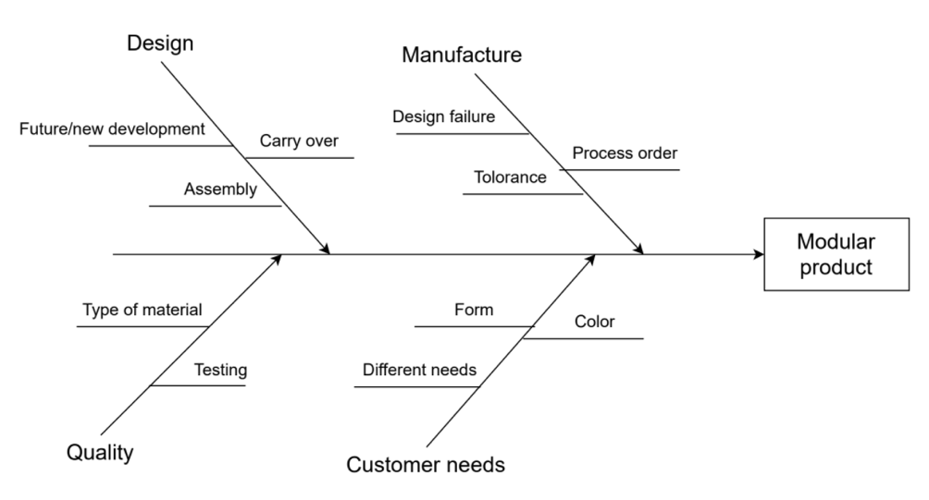

*Figure 2.8 Ishikawa for modular product*

Performance can be affected from three areas (design, materials, and technology). Things that affect the design of a coffee maker are the size, tolerance, and assembly. They play an important role because problems in tolerance assembly make the coffee maker not fulfilling its function. For example, not taking into consideration the standard Swedish kitchen height between the shelves (where most people have their coffee maker) might make your coffee maker useless if it doesn’t fit in the kitchen.

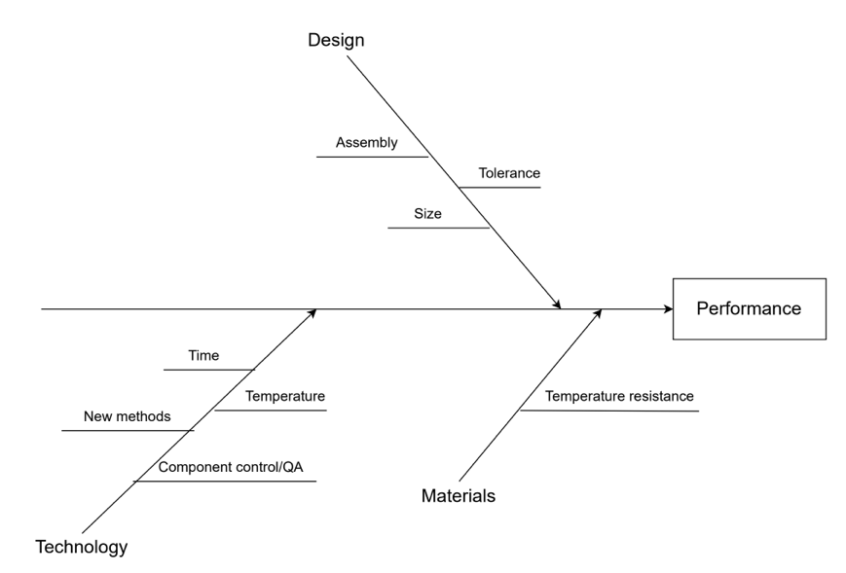

*Figure 2.9 Ishikawa diagram for performance*

## 2.7 Requirement specification for existing product

From the functional structure, specifications regarding the functions the coffee maker is expected to fulfill are derived. The BOM also gives rise to requirements about the materials used, and what is expected from them. The Ishikawa diagrams were used to derive requirements regarding our principal missions (environment, modularity, aesthetically pleasing for our customers, performant coffee market, and price concern). Also, Pugh’s balloons were used to provide a comprehensive list of requirements, covering most life cycle steps. The table of the requirements is in Appendix B or the excel file with path “*Requirement Specification/Requirement Specification*”, with a justification explaining their importance.

## 2.8 Functional structure - Existing product

Based on the steps above, a functional structure for the existing product was produced. See Figure 2.10 below.

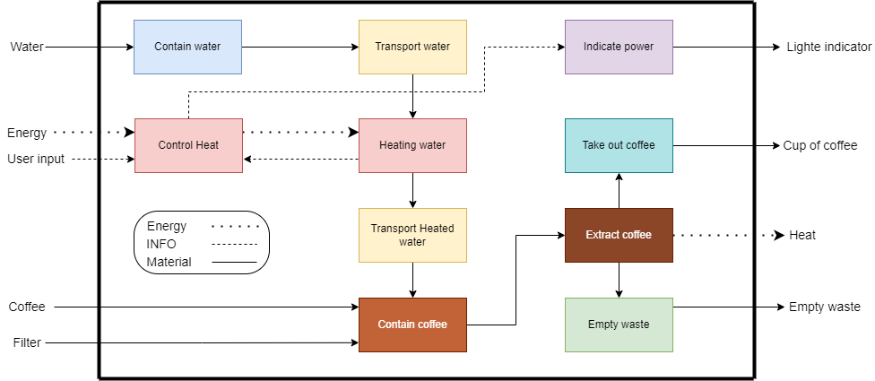

*Figure 2.10 Functional structure existing product*

## 2.9 LCA analysis – Existing product

The existing coffee machine’s environmental impact must be studied. This is done so that the design team can have an idea of the environmental impact expected for a coffee machine of that type of components. For that, a LCA assessment, using the EPS standard, is performed.

The table can be found in Appendix C

For the **pre-use** part of life cycle, **production** must be taken into consideration:

* Materials:

The materials (and their quantity) and processes used have already been identified in the BOM. From that, indices can be determined.

* Processes:

Assumptions were made regarding the processes used. For instance, it was assumed that all metal type off materials were to undergo "Stamping". Similarly, it was assumed that materials of "Plastic" type were subjected to "Injection molding". It is further justified by the fact that processes play a less important role in the estimation in comparison to materials.   
Depending on the materials that undergo each of the processes, indices are also calculated. For instance, 0.4547 kg of material are processed using injection molding. Knowing the ELU/kg for this process (0,0658 ELU/kg), the ELU index is calculated: 0.4547*0,0658 = 0,030 ELU.

* Life, Use:

Transportation needed to forage and transport the materials to the factory were disregarded, it was considered outside the life cycle.

For the **use** part of life cycle, **life** of the product must be taken into consideration:

**Life, Use**: the life of the coffee machine should be of about 10 years. To quantify the values, the following assumptions were made.

* Water:

It was considered that one cup required about 1dL, which weighs 0.1kg. If the machine is used to brew 2 cups a day, at the end of the machine’s life, 2*0.1*365*10 = 730 kg of water have been consumed. The water used to clean is not accounted for here.

* Coffee:

It was considered that one cup required about 10 grams. If the machine is used to brew 2 cups a day, at the end of the machine’s life, 2*10*365*10/1000 = 73kg of coffee have been consumed.

* Electricity:

The power rating is about 1000W. Considering the machine is used each day for 2min, in 10 years that makes an energy consumption of about 120 Wh.

* Average car:

This accounts for the most probable way the buyer will go to obtain the machine: with a car, at a retailer store. It was considered that the distance would be 4km.

For the **post-use** part of life cycle, 6 scenarios must be considered: reuse of components, reuse of material, combustion (energy is recovered), incineration (energy is not recovered), landfill and other (it can be compost for example).

First off, the existing components will never be reused as such. Considering 10 years as the life span of the machine, this latter will not undergo a controlled disassembly, thus no component, even if still functioning, will be reused in future products. So, there will be always **0% in reuse of components**.

PP:

* *Reuse - Material:* Some parts are easily removable (coffee grind container, caps for instance), so it's very likely those parts will be recycled. Once sorted out, they can thus be reused to fabricate other components. It was estimated it represented around **20% of the total weight**.
* *Combustion (energy recovery):* Since the disassembly of the machine will not be under control, the rest of PP will probably be thrown away: it is not expected for a regular user to disassemble each part. It is assumed **50%** of it will be burnt, but the energy created will be reused in the form of heating (common in Sweden)
* *Incineration (no energy recovery):* To account for the amount burnt without reuse of the energy, it is assumed **10%** of it will undergo this scenario.
* *Landfill:* As for the rest of the time (**20%**) it is possible that pieces are thrown away for landfill.

Cast: Aluminum

* *Reuse - Material:* Aluminum is very valuable to recycle. Chances are that a high proportion of it will be sorted out, hence **40%** of it will undergo this scenario. It cannot be higher, because aluminum is mostly present in the heating element and this piece is located inside: it cannot be guaranteed that most users will dismantle it.
* *Combustion (energy recovery):* Metals, like aluminum, are not likely to be burnt for energy recovery. Hence **0%.**
* *Incineration (no energy recovery):* Most users will probably throw away the machine without consideration of components inside. That's why most of it, **55%, is assumed to be burnt in an incineration process**.
* *Landfill*: As for the rest of the time (**5%**) it is possible that the component like the heating component, ends up as landfill.

Sheet: Low-alloy steel, high

We assumed low-alloy steel to have the same behavior than aluminum. Hence the proportions:

* Reuse - Material: **40%**
* Combustion (energy recovery): **0%**
* Incineration (no energy recovery): **55%**
* Landfill: **5%**

Silicon rubber

* *Incineration (no energy recovery):* Given the size of the component, it will most than likely end up being used in this scenario. Hence **100%** of the silicon components will be incinerated.

Ceramic

We assumed Ceramic to have the same behavior than Silicon rubber (given the size of the components and their placement). Hence the proportions:

* *Incineration (no energy recovery):* Given the size of the component, it will most than likely end up being used in this scenario. Hence 100% of the ceramic components will be incinerated.

PVC

* *Reuse - Material:* **75%** of it will be reused (material), because PVC is easily recycled.
* *Combustion (energy recovery):* **10%** some non-sorted-out components will be burnt in combustion (for heating, in Sweden)
* *Landfill:* **15%** of it will end up in landfill, along with the non-sorted out components

PBT

* *Reuse - Material:* **0%** of it will be reused (material), because unlike PVC, PBT is hardly recycled.
* *Incineration (no energy recovery):* **100%** (that is, the feet of the coffee machine) will most likely staying attached to the casing, and thrown away with the casing. Without distinction, it will then end up being burnt in incineration without energy recovery.

Results: the total is about 177ELU.

## 2.10 DFA – Existing product

After disassembling the existing product, the procedure for the DFA was to first imagine how the coffee machine was assembled. The product was re-assembled in steps and the type of fastening for the components was noted (for example if the component was screwed or attached using clips). The entire assembling procedure was documented in a word file. A total of 22 steps were identified. To do the DFA analysis, the software AVIX was used (see figure 2.11). The purpose of this is to study the ease of assembly and most importantly find a way of reducing the number of parts. A total of 8 questions are asked for each assembly step and once completed a final DFA value is presented. For the existing product the DFA value was 84% and had an assembly time of 114 seconds. The existing machine has a good DFA score and it will be challenging to the development team to get better score.

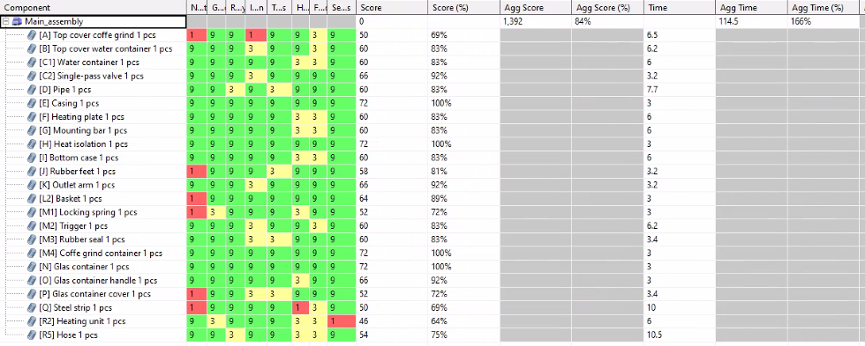

*Figure 2.11 DFA for existing product*

# Chapter 3: Redesign

## 3.1 Functional structure – New product

After the reverse engineering, the redesign initialized with creating a functional structure for the new product, based on the understanding gained. See figure 3.1 below for the result.

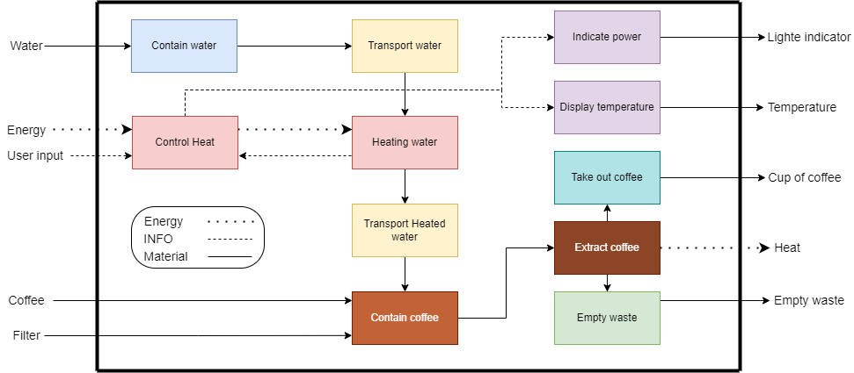

*Figure 3.1 Functional structure new product*

Note: There is a little problem in the figure 3.1. The problem is the arrows at the output side at “*Temperature*” and “*Light indicator*” should be (---------) because the arrow is of type *INFO.*

## 3.2 Scenario description for two market segments

### 3.2.1 Families

Sara is a 30-year-old teacher, and she is a coffee lover, but she can’t drink her coffee because of her kids, and she needs to keep heating the coffee maker because it gets cold while she helps her kids. During one of Sara’s holidays, she gets a phone call and goes out of the kitchen, when she returns and opens the door, she sees her three small kids (3-8 years) playing in the kitchen and having all the forks and spoons down. One of the kids dragged the coffee maker which made it fall and the coffee that Sara was waiting for is now on the carpet and one of the kid’s legs got burned. The smallest kid was eating the brewed coffee from the coffee container thinking it was chocolate and the dog was barking and running because he burned his tongue because he licked the coffee from the broken coffee container. Sara becomes sad and angry because she doesn’t know where to start cleaning and what to do for the burned kid and the dog. She also knows that buying a new coffee maker means less milk for her kids because she is already on a low budget.

Sara was always complaining about having a small apartment and the kitchen was very hard to organize. That made her use one of the kitchen chairs as a place to put the *Nido* powdered milk because the kitchen shelves were full. On the next day, her mom visited her and told her to stop buying stuff, but Sara isn’t buying new stuff she is buying only necessary products for her kids.

### 3.2.2 Upper class

Reginald comes home after a long day of work. He may be an executive, he still has to commute like anybody else. He finds it very tiring, especially when the Uber driver cannot make it and he is doomed to take public transportation. So, when he crosses the threshold of the duplex he rented for his business trip, he doesn’t want to feel like anybody else. Reginald deserves to feel special, to feel appreciated for the hard work he does. Almost machinally, he heads towards the kitchen, where he is confronted with the harrowing view of a toy-like coffee machine. He saw it this morning already and here it is again, cheap-looking as ever. He sighs heavily, then smiles to himself: it looks like it could break at any moment, and perhaps he shouldn’t breathe too much? Who knows, it’s so light that it might get blown away! Reginald is reasonable though, he switches the machine on, and waits for the black liquid to drip down for him to prepare for the next day's meeting. But that’s the thing: the machine takes forever, stealing the precious minutes he could have used to put the finishing touches to his PowerPoint presentation.

Reginald, still waiting, then imagined his perfect coffee maker: it would be quick, and a pleasure for his eyes! It would encourage him to work through the evening when he comes back after an exhausting day.

## 3.3 Mood boards

### 3.3.1 Mood board for families

The family wants to save money and space. But they also want their product to be durable in form of life and time it can contain heat. It should also be repairable, modular, and environmentally friendly.



*Figure 3.2 Mood board families*

### 3.3.2 Mood board for the upper class

The upper-class care about material, time, and design. They want their coffee maker to be exclusive and durable.



*Figure 3.3 Mood board upper class people*

## 3.4 Design evaluation of price segments

To evaluate the design of existing products in the market, two price segments were investigated: One for products with a price between 0-500 SEK and one with a price of 1000-2000 SEK. Three products were evaluated for each price segment. The design was evaluated for the geometric quality, material selection, surface finishing and color matching and each parameter were weighted between a scale of 1-3, where a higher number is better. The winning design was the *Moccamaster* Manual in black color with a total score of 15. See figure 3.4 for the benchmark below.

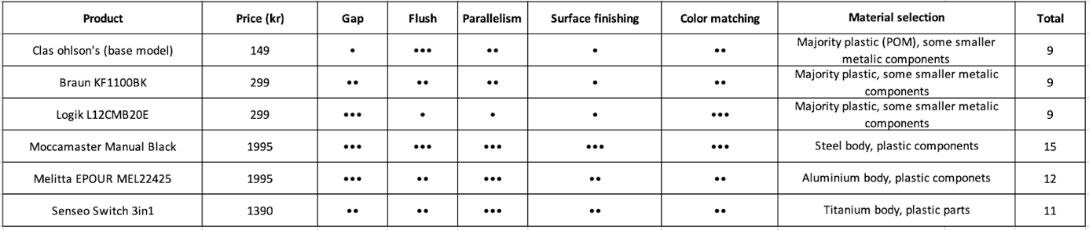

*Figure 3.4 Design evaluation of price segments*

## 3.5 Differentiation plan

Since one of the chosen segments are families, a coffee machine that can fill 4-5 cups of coffee would be suitable. Same concept goes for the upper class, but wealthy people would not care much about a bigger machine, because it would not look very special, i.e. the size of the coffee machine is different for these market segments. Additional difference between the segments is the material selection of the machine, a wealthy family would like to have a certain coffee machine that has some expensive and fancy details. For the middle class an affordable and big machine would be more suitable than an overpriced fancy one. Besides the size and the price of the machine there is another important factor that middle class parents take into consideration, and that is safety and space saving. A different design for the coffee machine would be a wall-mounted machine. The machine is now a bit higher than a normal designed machine which can save space for other things in the kitchen. Additional benefit of wall-mounted design is that kids can’t reach it and therefore are considered as safe.

## 3.6 Requirement specification – New product

The requirement specification was split for both market segments. Some of the requirements were shared for both products like for example handle a kitchen environment and some components being washable. In other ways they differed in that the family for example cares more about the environment but less about the material types. Another factor is that a family want a product that is cost effective and perhaps be able to replace parts in case it breaks. The upper-class people want a product that feels exclusive, produces great coffee and cares more about the material. To see the requirement specification for the new product, see Appendix D

## 3.7 Concept generation

The concept generation started with creating solutions for each function after studying the functional structure of the existing product. The first step was brainstorming ideas on how to solve the functions by producing drawings, or through discussing ideas. After the brainstorming session, a morphologic matrix was generated to help generate solutions for the subfunctions (See appendix E). The solutions for each function were combined to create multiple complete concepts. A total of 10 concepts were generated, and 3 of these were seen as a passable solution because the other solutions were too hard to implement.

Next, the 3 remaining concepts were drawn in further detail and the functions was further explained.





After that a CAD model for the concepts were constructed to further help with visualizing the final product. The next step was using the Kesselring matrix to further study the concepts in detail and decide which is the best to proceed with and develop. The Kesselring matrix requires the weight of parameters. The weight of parameters is developed by comparing different criteria that are important for the product. The criterias are from the goals of this project (consider costs and modularity), Ishikawa diagrams and requirement specifications. Manufacturing costs, manufacturing feasibility and ergonomics are important parameters from the requirement specifications for the manufacturers. The reason for having them is to develop a product that considers the whole chain. Other significant criteria are reparability, durability, safety, environmentally friendly and design. When the criteria are compared, a value of 0, 0.5 or 1 can be given. The weight parameter for a criterion is calculated by using the values and dividing them by the total sum. The winning concept in this case was concept 2. To see the Kesselring matrix, (see appendix F). 

In the Kesselring matrix the weight of criteria is multiplied by the solutions grade of that criteria and when the same process is done for each criteria a sum should be evaluated, which is total weight value another important parameter is the number of weak points which is the number of “ones” in different solutions.

## 3.8 Compilation drawing & order of assembly

To visualize how the different parts are assembled and how many parts is there in the total assembly, a drawing of the new machine with an exploded view is needed (figure 3.6). Furthermore, just by looking at the view can tell us how modular the product is.

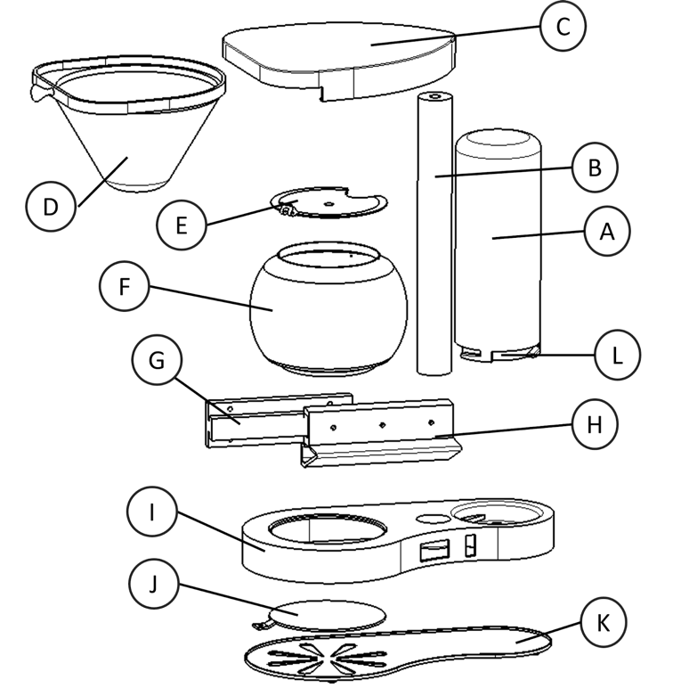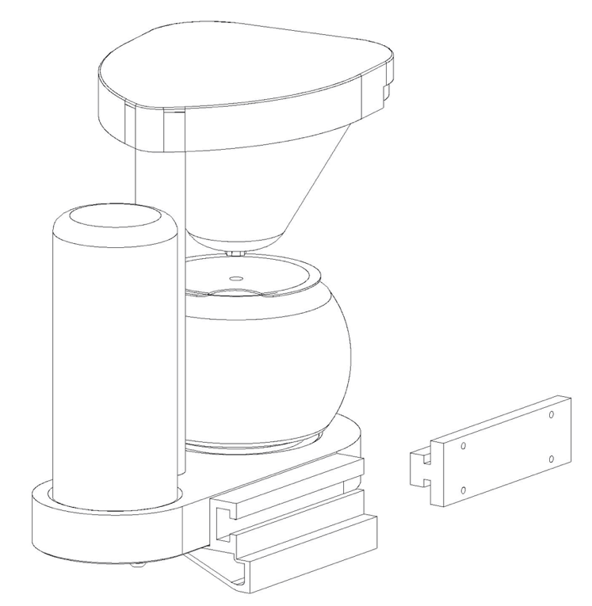



Order of assembly: The new machine is designed to get good DFA score and that is why the machine can be easily assembled in the following steps:

Note: The reference letter from figure 3,6 and the part name can be matched using (appendix I)

Step 1: Mount *J* to *I.*

Step 2: Mount the *heating element* to *I*.

Step 3: Mount the *single bypass valve* to *I.*

Step 4: Mount two hoses from the heating element to {I.water inlet & I.socket}.

Step 5: Mount the *control unit* to *I*.

Step 6: Mount *Switch and display* to *I*.

Step 7: Mount the *insolation sheet* to *K*.

Step 8: Mount *K* to *I.*

Step 9: Mount *B* to *I*.

Step 10: Mount *C* to *B.*

Step 11: Mount *L* to *A.*

Step 12: Secure *Step11* to *I.*

Step 13: Slide *D* in *C*

Step 14: Mount *Handle* to *Handle Joint.*

Step 15: Mount *Step 14* to *F*.

Step 16: Put *Step15* in the machine on *I.*

## 3.9 Drawing of the three most important parts

The mounting bars are critical parts because they are holding the whole machine. If any failure occurs to them, hot coffee or water could spill outside their container and could also damage the electrical part. Because of that a detailed drawing of the mounting bars is necessary (see figure 3.7 and 3.8).

The coffee container holder support is also a critical part because it has multifunction at the same time. It will be mounted to the Pipe Casing and hold the Coffee Grounds Container by a slot with an opening with 148 mm. The outlet arm is integrated into this part which makes the whole Coffee Container Holder Support more critical. (see figure 3.9)







# Chapter 4: Material selection

Based on the requirement specifications derived for each market segment, materials are chosen for the handle and for the heating plate. The material section was done in parallel with concept generation.

It is of the upmost importance that the handle satisfies the expectations of the user: this part will be looked and touched each time the user brew coffee. Also, one area of interest is to provide families with a heating plate capable of supplying heat to the brewed coffee for a relatively long time. It is indeed a requirement, since families want to keep the large quantity of brewed coffee warm long enough so that everybody can have a drink. It is also a matter of interest for the upper class, since it isn’t something, they expect it is a feature of delight, contributing to the overall satisfaction of the user of that market segment. Also, the material selection for the casing and the bar will be discussed. For further details regarding material selection matters, refer to Appendix D

## 4.1 Handle: Families

The approach is to determine the function of the component, based on the requirements and goals for the material it is made of. Also, environmental constraints will be considered. The initial material is Polypropylene (PP).

|  |  |  |
| --- | --- | --- |
| Function | The function of the handle is to provide a *holdable*, *touchable* surface when manipulating the kettle, which may contain a hot liquid. | |
| Requirement profile | Requirements | * Withstand water (fresh) * Withstand weak alkalis * Withstand organic solvents * Have a lesser thermal conductivity than that of PP * Surface treatment allows sufficient grip |
| Goals | * Minimize price * Maximize M = sqrt(Ef)/ p= [Flexural modulus]/ [Density] * Minimize environmental impact |

First, the function of the component is formulated. In that case, it was established that a handle must:

|  |
| --- |
| Provide a holdable, touchable surface when manipulating the kettle, which may contain a hot liquid. |

For the surface to be holdable, the relevant performance index was identified to be (beam in bending):

M=sqrt(Ef) / p

With Ef the flexural modulus and pthe density. Maximizing M will allow for a stiff and light handle. This results in the following equation:

log(Ef)=2log(M)+2log(p)

The slope is thus 2.

Once the limits regarding the environment (water, alkalis, organic solvents) and thermal conductivity (which is important to provide a *touchable* part) have been taken into account, the performance index line is moved up to select the best materials.

The requirement regarding surface roughness is not taken into consideration here, since it has to do with the process, not the material selection.

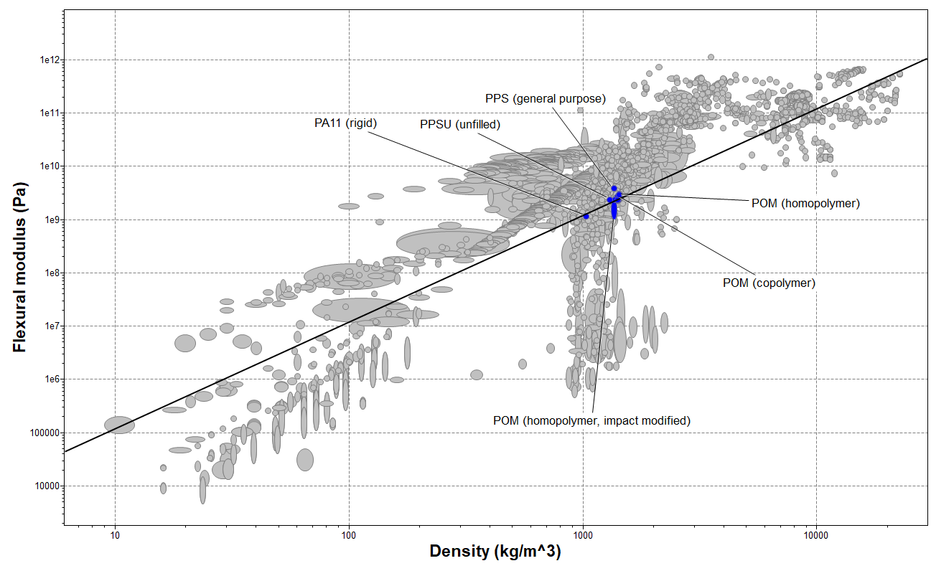

*Figure 4.1 - Flexural modulus agaisnt density*

The graph above is obtained (figure 4.1). The materials passing the stages are PPS, several types of POM, PPSU and PA11. In order to make a choice, desirables will be included. A plot of the materials price and CO2 footprint is thus established.

It is worth noting that at this point, the design team decided to prioritize materials that could be recycled, rather than materials which would be biodegradable for example. From the perspective that the machine’s life should be as long as possible, more inert materials like polymers and metals appeared as a better choice.

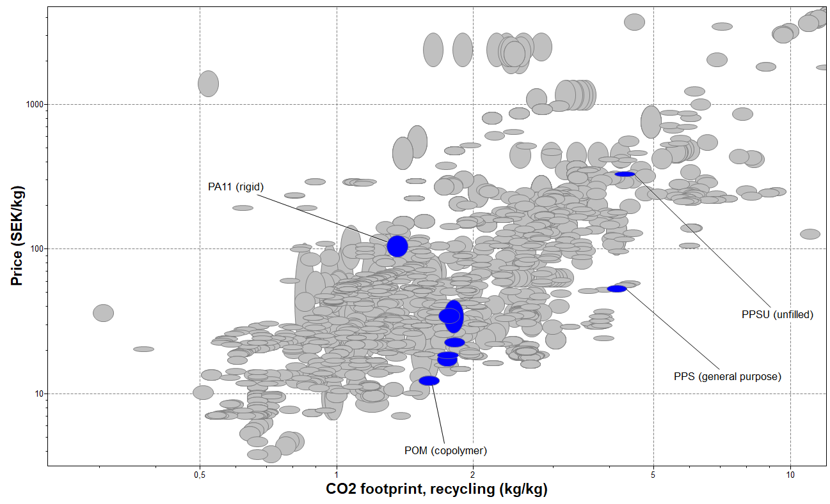

*Figure 4.2 - Price agaisnt CO2 footprint*

The plot obtained shows that POM (copolymer) is the cheapest material, for a reasonable CO2 footprint. (Figure 4.2)

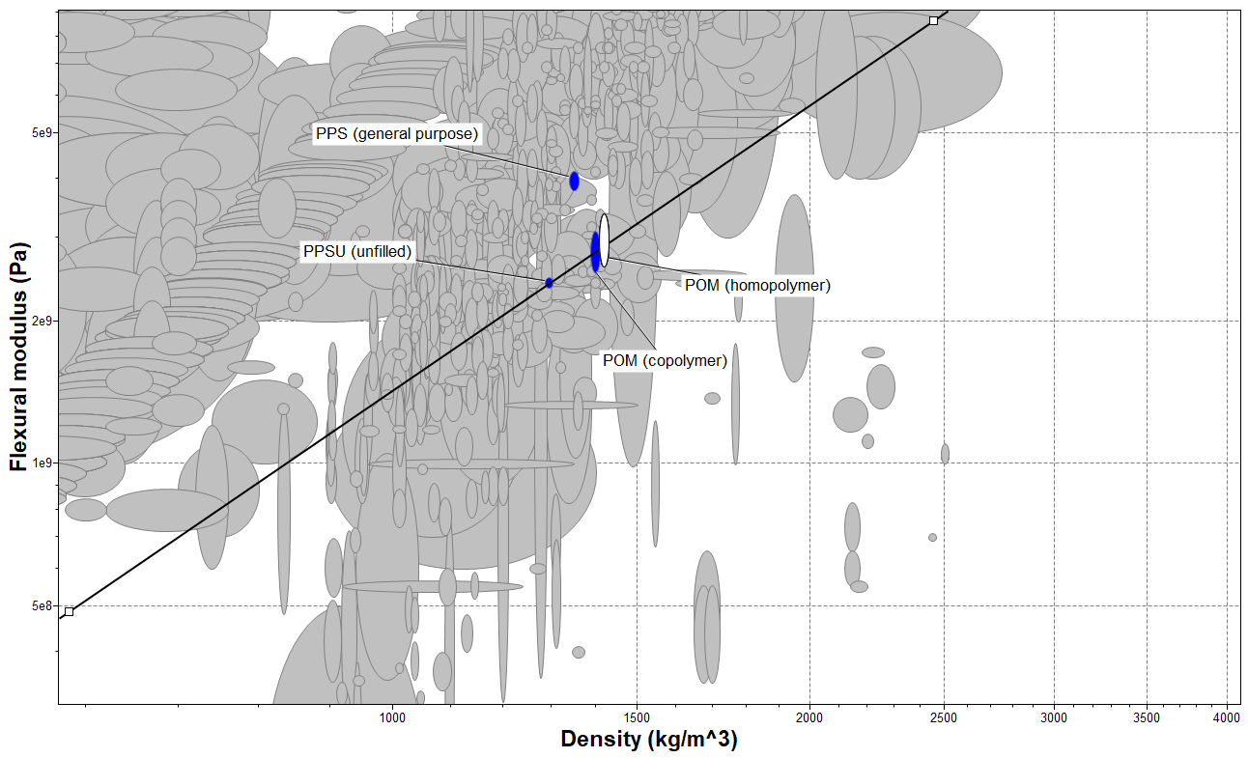

*Figure 4.3 - Zoom on the Flexural modulus agaisnt the Density*

Zooming in, it can be seen that the performance of POM (copolymer) is about second best compared to PPS, but the latter is more expensive and less environmentally friendly.

Now, the melting point of POM (copolymer) and its usages can be checked for a more thorough choice:

* Amongst common industrial usages, there are “domestic appliances housings”, and “electrical kettles”;
* Melting point is between 160 - 170°C: it is suited for the intended usage

Finally, to anticipate needs for surface treatment, possible processes can be checked: abrasive blasting and texturing are available.

Conclusion:

|  |
| --- |
| The component “Handle” for the market segment family will be made of **POM (copolymer)**. |

## 4.2 Casing: families

The choice of POM for the handle is further motivated by the fact that the casing can be also manufactured with the same material: that would result in less suppliers, so decreased manufacturing costs. POM can also be manufactured with injection molding, which is good from a reduced-cost point of view. Moreover, the casing share similar requirements with the handle.

For those reasons,

|  |
| --- |
| The component “Casing” for the market segment family will be made of **POM (copolymer)**. |

## 4.3 Handle: Upper class

For the upper-class version, some requirements such as: luxurious looking and at the same time easy to manufacture are made. The handle will be made of epoxy mixed with brass powder. The epoxy has been chosen because it looks nice, and its thermal conductivity is very low which will keep the handle in the room’s temperature. The manufacturing process of the epoxy is not difficult. It can be casted in the rooms temperature into flexible molds.

## 4.4 Heating plate

|  |  |  |
| --- | --- | --- |
| Function | The function of the plate is to provide a *heating* function to the bottom of the kettle. | |
| Requirement profile | Requirements | * Withstand weak acid * Withstand organic solvents * Withstand fresh water * Withstand weak alkalis |
| Goals | * Minimize price * Minimize insulation = maximize heat loss |

With a similar approach, once the function determined, a suitable performance index is derived. Here,

M = λ / ([Price]*p)

Instead of minimizing it, the goal will be to maximize it to encourage heat transfer from the plate to the glass container. Price was added to take into consideration (int he denominator) the goal of minimizing the price.

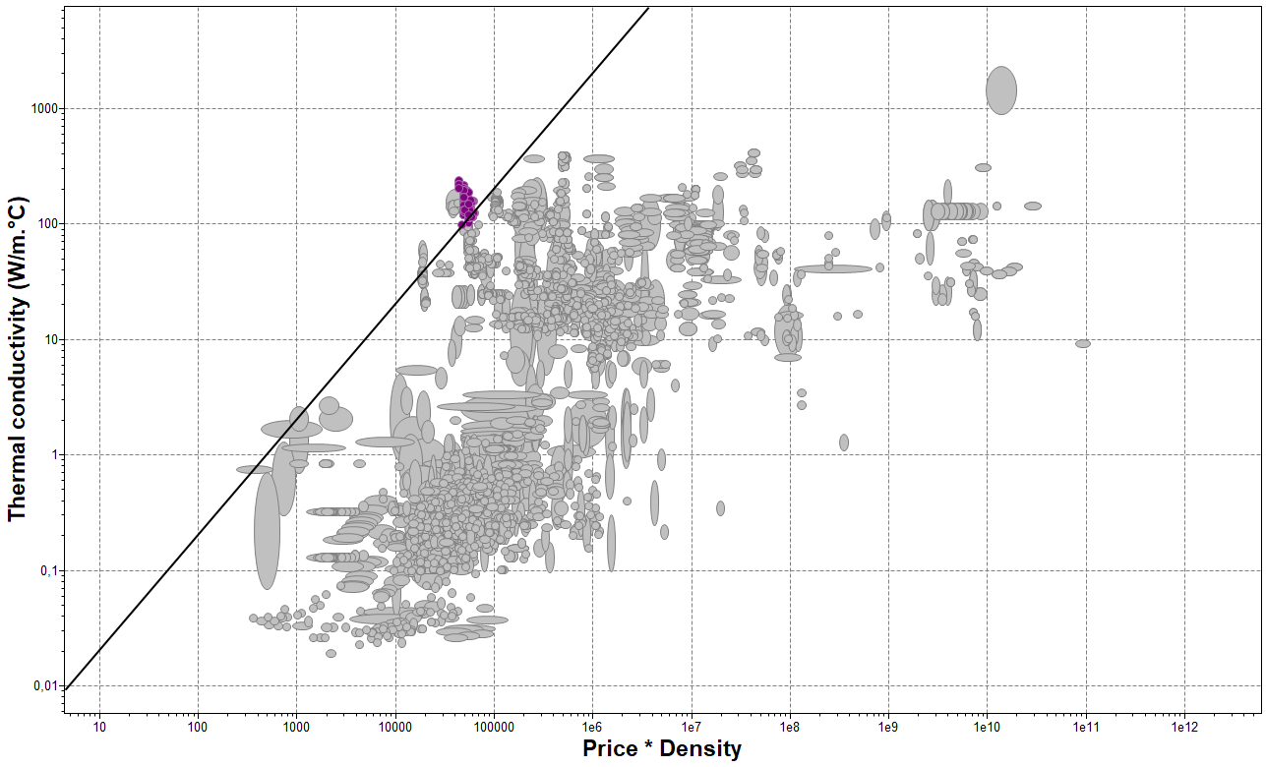

*Figure 4.4 - Thermal conductivity against Price*Density*

The most suited elements are all **Aluminum**.

Aluminum can support several surface treatment processes, which is interesting if texturizing is needed to help with preventing noticeable scratches. Also, choosing the same materials for both market segments is motivated by the fact that it will allow one process of manufacturing this piece, and that only one supplier will be needed for Aluminum material.

Conclusion:

|  |
| --- |
| The component “Heating plate” for both market segments will be made of **Aluminum**. |

## 4.5 Sliding elements

|  |  |  |
| --- | --- | --- |
| Function | The function of the Case bar and Wall bar is to allow the rest of the coffee machine to *attach* to a wall. | |
| Requirement profile | Goals | * Minimize price * Maximize M = sqrt(Ef)/ p= [Flexural modulus]/ [Density] * Minimize environmental impact |

The function of the sliding elements is to allow the coffee machine to be safely attached to the wall. As such, the mechanical load applied to the elements Case Bar and Wall Bar are such that their main goal is to sustain the torque applied. So, they must be as stiff as possible, whilst being light. Therefore, the following index is used:

M = sqrt(Ef)/ p

With Ef the flexural modulus and pthe density.

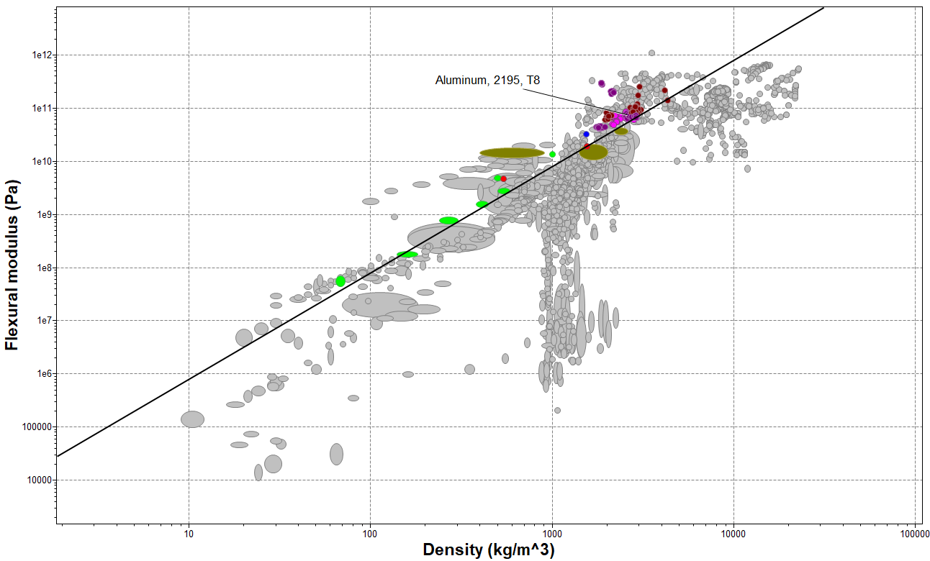

*Figure 4.5 - Flexural modulus against Density*

From all the materials the plot presents, foams (bright green) and concretes (khaki) are eliminated. Glasses are too brittle, they are also eliminated. Different aluminums and beryllium alloys are left.

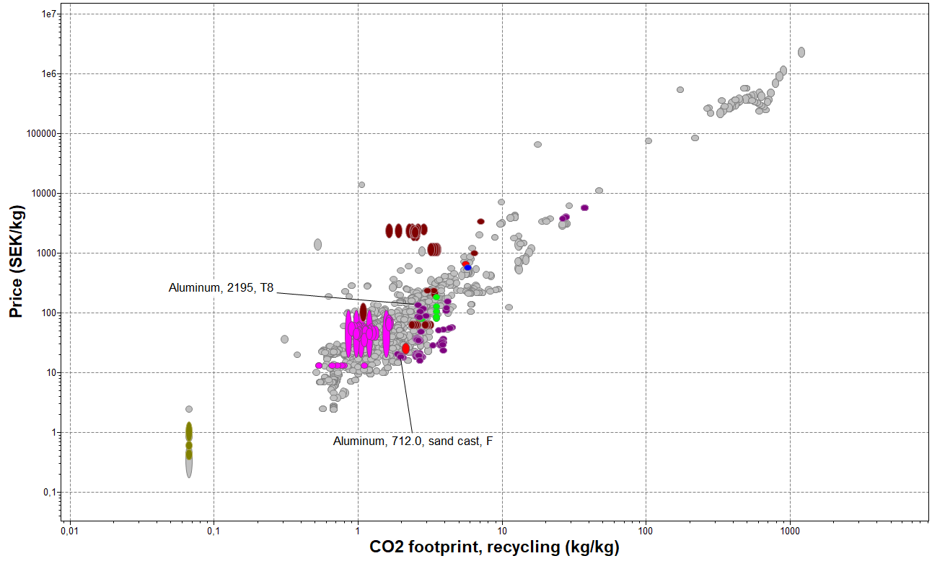

*Figure 4.6 - Price against CO2 footprint*

Looking at price and the CO2 footprint (the market segment “Families” are concerned with it), excluding concretes and glass, the same materials are left. But reading common usages, Aluminum is the most reasonable choice.

Conclusion:

|  |
| --- |
| The components “Case Bar” and “Wall Bar” for the market segment “Families” will be made of **Aluminum**. |

## 4.6 Casing for the upper class

|  |  |  |
| --- | --- | --- |
| Function | The function of the casing to provide a *structure* to the components. | |
| Requirement profile | Requirements | * Withstand acetic acid (10%) * Withstand sodium hydroxide (10%) * Withstand fresh water * Withstand vegetable oils (general) |
| Goals | * Maximize M = [Young’s modulus] /[Density] * Minimize thermal distortion for given heat flux: maximize M = [Thermal conductivity] /[Thermal expansion coefficient] * Optimize mass; minimum heat flux at steady state; thickness specified: maximize M = [Density] /[Thermal conductivity] * Optimize energy stored for given temperature rise and time: Maximize M = [Thermal conductivity]*[Density]*[Price] |

For this material selection, the database used in the software Granta Edupack is Level 2.

The requirements have to do with the environment of the coffee machine (kitchen).

The performances indexes looked at are:

First, the stiffness and the mass of the material: the material looked for should be as stiff as possible whilst being light (it was established that the casing should be heavy in order to convey the idea of high quality, however it cannot be too heavy, otherwise it would no feel ergonomic).

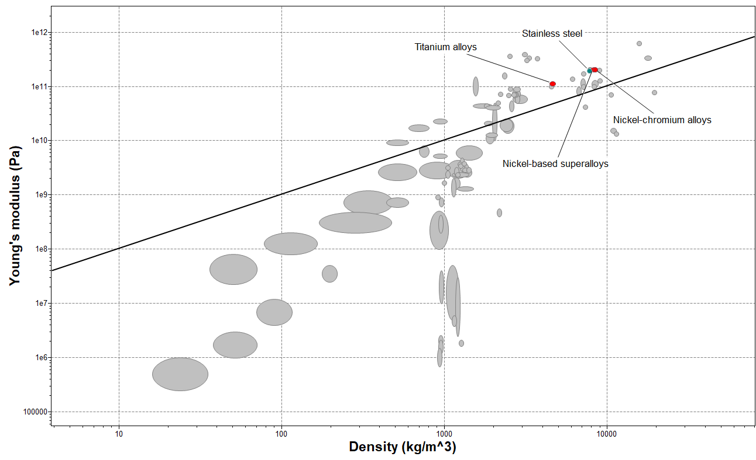

*Figure 4.7 - Young’s modulus agaisnt Density*

Titanium alloys, Nickel-chromium alloys, Nickel-based superalloys and Stainless steel are the best materials. Next, the casing protects the heating element. However, the casing should not change shape due to thermic loads: it could jeopardize the assembly, the sealproofness of some parts.

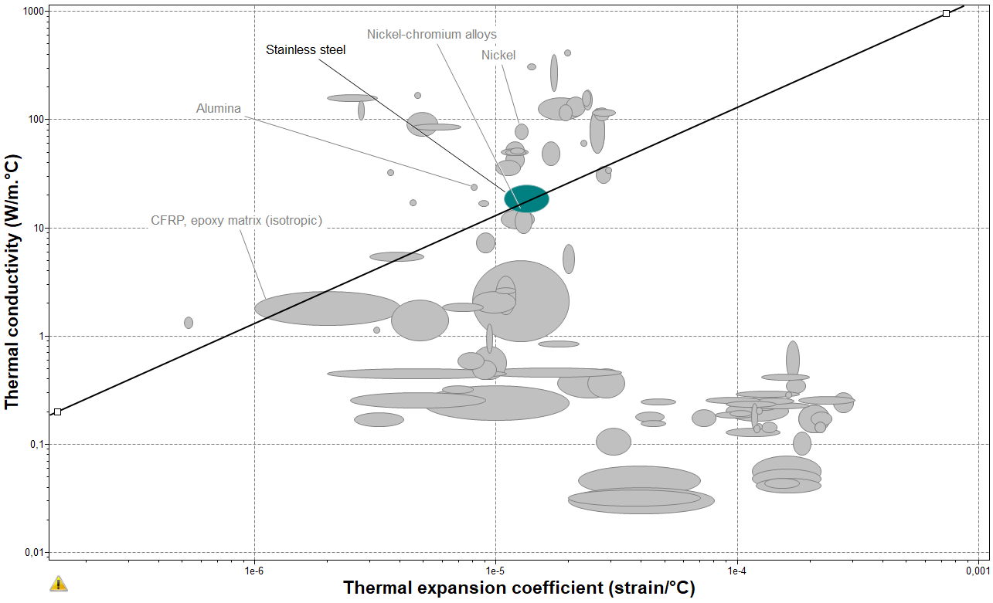

*Figure 4.8 - Thermal conductivity agaisnt Thermal expansion coefficient*

Stainless steel is the best material regarding this aspect. Common usages are appliances.

From those two performance indices, the material chosen for the casing would be Stainless steel. But to be more thorough, other important indices will be checked, to make sure stainless steel is still qualified.

Also, thermic isolation must be optimized: when the heating element heats up, or that hot water passes through inside the machine, the goal is to minimize the heat flux. Indeed, it has to do with safety requirements, regarding of the maximum temperature of touchable parts.

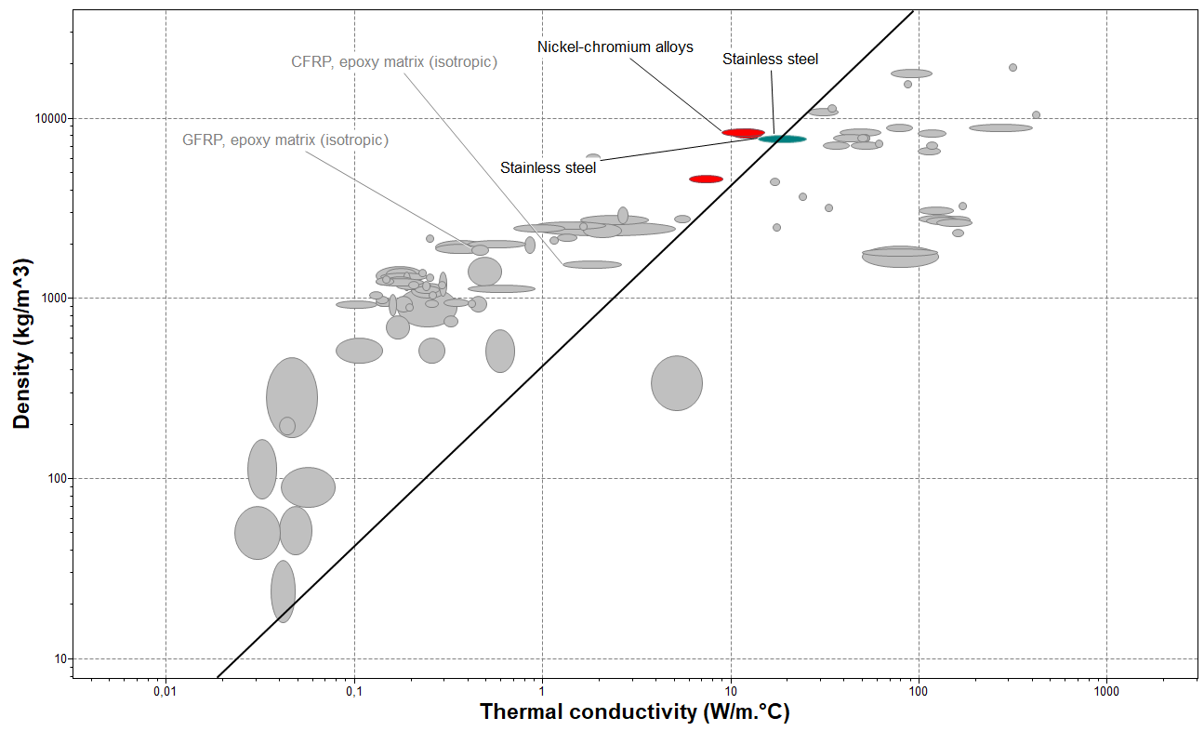

*Figure 4.9 - Density agaisnt Thermal conductivity*

Finally, the energy stored for given temperature rise and time also has to be optimized, for similar reasons.

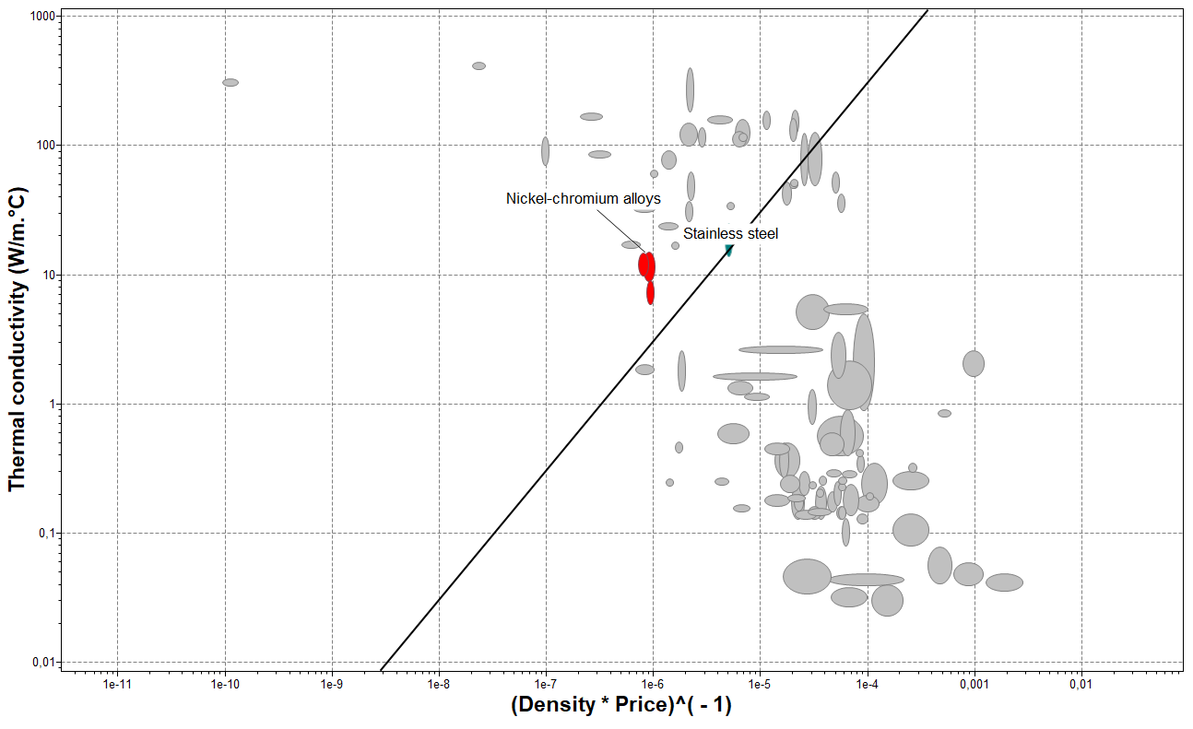

*Figure 4.10 - Thermal conductivity against 1/(Density*Price)*

Stainless steel also qualifies regarding this aspect.

Conclusion:

|  |
| --- |
| The “Casing” for the market segment “Upper class” will be made of **Stainless steel**. |

# Chapter 5: Modelling & Analysis

## 5.1 RD&T Analysis

### 5.1.1 Stability analysis for part

Stability analysis is a type of analysis done in the early phases to maximize the robustness of a product. Robustness means that the coffee maker is insensitive to variation. In other words, the input of the coffee maker (locator's position) should not influence the output (the design). For the adapted coffee maker, the red color indicated a high sensitivity, green is medium, and blue indicates low sensitivity (see figure 5.1). In this case the mounting bar is very sensitive to variation. But the good news is that the mounting bar is fixed on the wall and this kind of variation wouldn't affect the coffee maker, because the mounting bar is the ground/base.

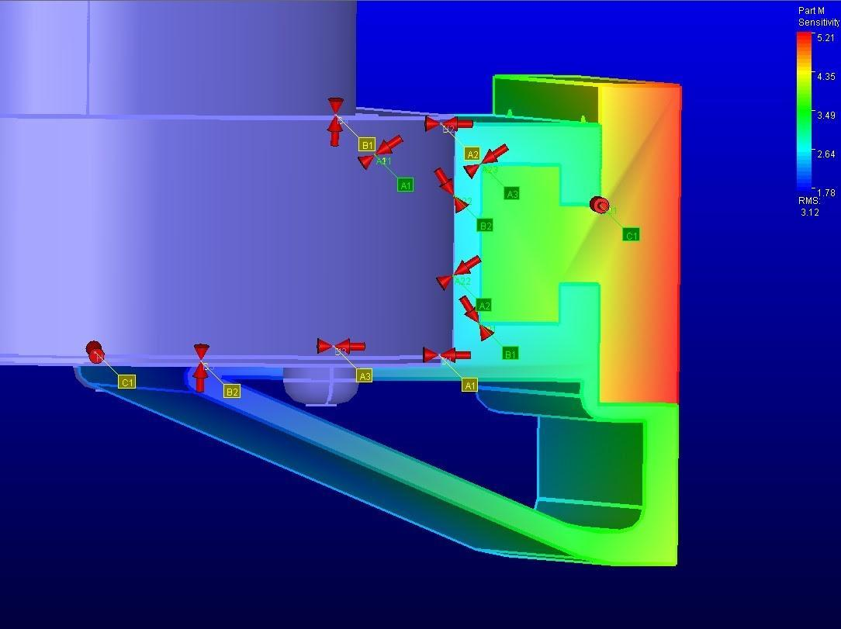

*Figure 5.1 Color coding in RD&T*

### 5.1.2 Stability analysis for measure

A value higher than 1 indicates weak robustness and sensitivity and the opposite represents high robustness (figure 5.2). Only the last two points (A3 and C1) have a high level of robustness and low sensitivity.

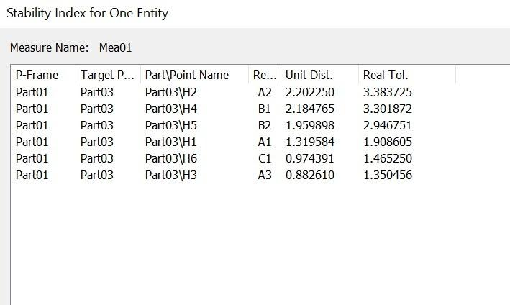

*Figure 5.2 Stability index for one entity*

### 5.1.3 Variation analysis

In the variation analysis, a point (point-self) was chosen to see by how many millimeters tends the coffee machine to bend/turn to the sides. The variation analysis uses Monte Carlo simulation method to analyze the variation in e.g. “Point-Self” or “Point to Point.” After a statistical simulation with 1000 runs the result is shown in the figure 5.3.

The point “Mea01” has a variation between 5.77 and -5.66 millimeters and a mean of 0.0506 (see figure 5.3) The mean is close to zero which means the quality of the coffee machine is high and the customer that buys the coffee maker will still be able to use it even if the variation is existing. Another important parameter to check if the group can meet customer requirements and which areas to improve, is the standard deviation which is a measure of variation. Most of our points will be 1.43 from the mean, which is a low value. The variation is not so spread out and it's close to the mean, which is good sign. The Cp is an indicator of the process capability which gives information about the variation in the manufacturing process. In figure 5.3 the Cp is 2.33 which means that the standard deviation (std) is small and that indicates that variation is close to the mean.

Cp and Cpk are both called process capability. The reason of using them is to predict whether the coffee maker can be mass produced or not. And therefore, meet the customer requirements and specifications (upper and lower limits) otherwise this leads to losses for the company.

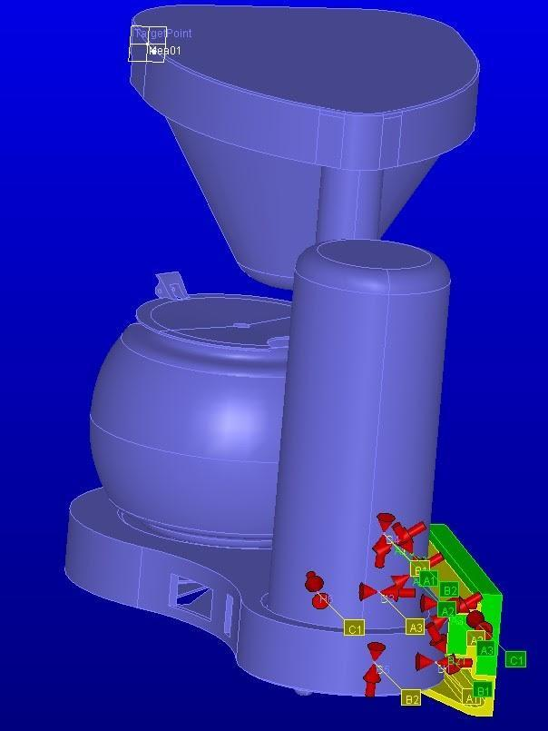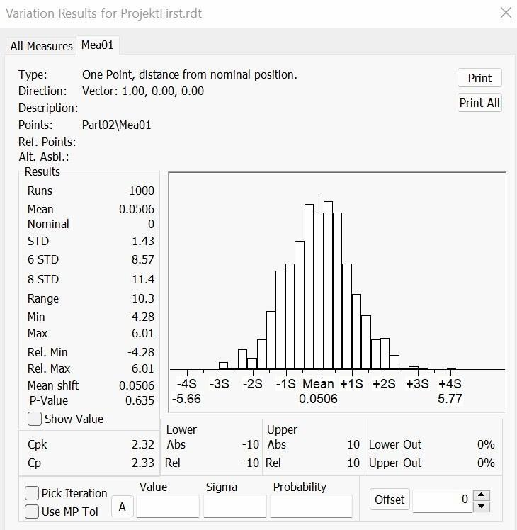

### 5.1.4 Contribution analysis

The reason for using contribution analysis is to show the list of points and tolerances that contributes to a measure variation. In this case the 4 points that contribute the most to variation in “Mea01” are points H2, B2, H4 and B1 (see figure 5.4 – 5.8) and they contribute more than 13% of variation which is a bit high. A way of improving the coffee machine is to change the position of the locators or change the tolerance but a change in tolerance means more costs for the company. Therefore, changing the place for the four points is a good solution.

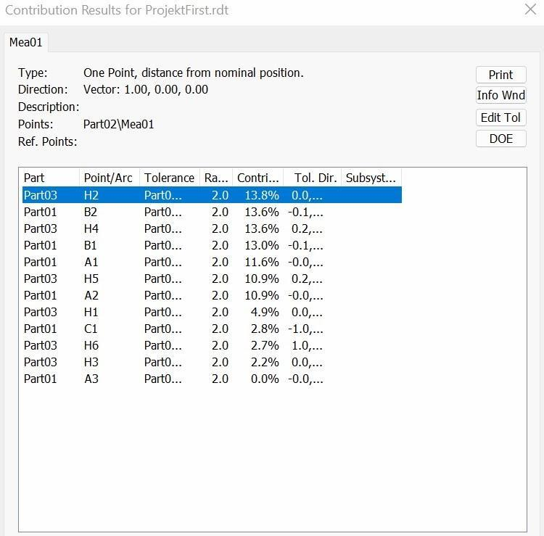

*Figure 5.4 Contribution results*

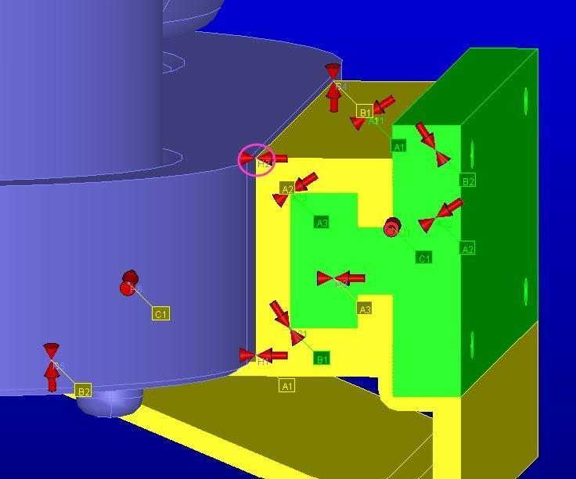

*Figure 5.5 Point H2 in circle*

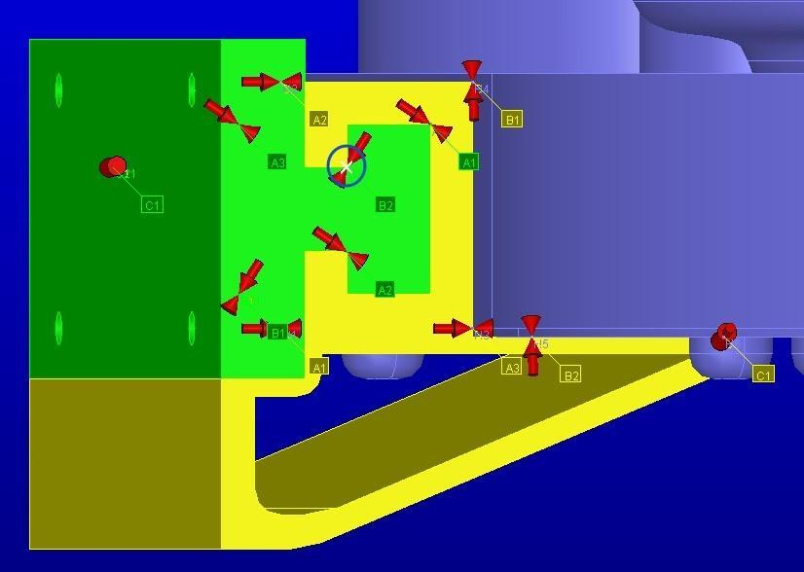

*Figure 5.6 Point B2 in circle*

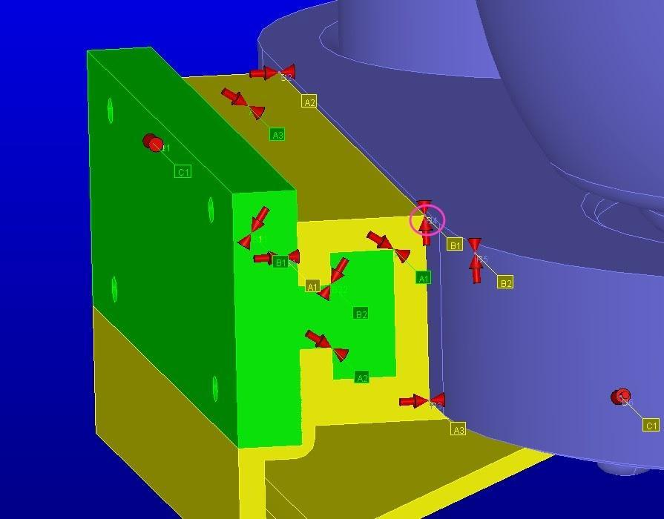

*Figure 5.7 Point H4 in circle*

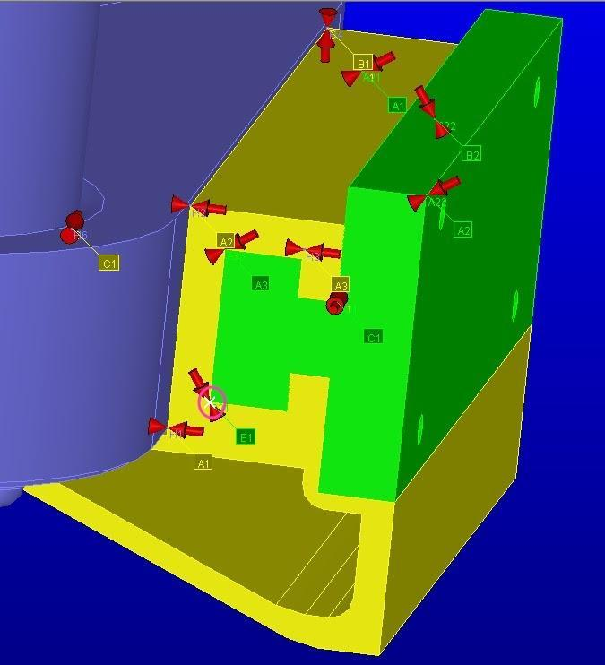

*Figure 5.8 Point B1 in circle*

## 5.2 LCA – New product

The new coffee machine’s environmental impact must be studied. For that, a LCA analysis, using the EPS standard, is also performed. The aim of this study is to compare the environmental impact of the new coffee machine concept with a coffee machine already exist on the market.

LCA is performed to assess the environment profile of the final concept. See appendix J.

It was established that the market segment of families is sensible to environmentally friendly products. As for the upper-class market segment, it is not considered to be a decisive criterion. To estimate the total index, for each variant, a similar approach was taken.

1) Determination of indices:

Materials were identified via the Bill Of Material. For each material, we use the weight calculated.

One significant constraint is that every index isn’t available: some materials selected do not have a corresponding ELU index, as well as some processes. For example, Epoxy is a material selected for the handle of the variant of the upper-class segment. For lack of an index, the indices for Polyurethane (PU) were chosen instead. The same approach holds for processes chosen. As such, the following processes will share the same index:

* Injection molding.
* Casting.
* Blow molding.
* Extrusion.

Lastly, for metals both plain and sheet type of materials can be chosen. To make the decision, for each component, the process used had to be taken into consideration. For instance, “low-alloy steel” was considered to be “steel”, in “sheet” form since the processes were “wire bending” and “metal punching”.

2) Proposition for end-of-life scenarios

One example is given below for the “family” market segment. Comments for each end-of-life scenario are in the excel file sheet path: “*Group-1-Project-MMF092/* *LCA-Existing-and-New-Product/Family*”

The new design components do not share the same end-of-life scenarios (in comparison with the existing product): some components are more easily accessible, making aluminum components more likely to be recycled rather than thrown away.

The total weight of aluminum (cast) present in the machine is 0,59051 kg. It accounts for 3 elements:

* Case Bar and Wall Bar.
* Heating Element.

What is the proportion likely to be recycled? The organ comprising the “*Wall bar*” as well as the “*Case bar*” will likely always be sorted out to enter recycling since it’s so visible. It represents around 83% of the Aluminum (cast) weight. Sometimes, some elements may get recycled as well, hence the proportion of recycled Aluminum components is rounded to 80%.

The resulting environmental load is showed in figure 5.9 below

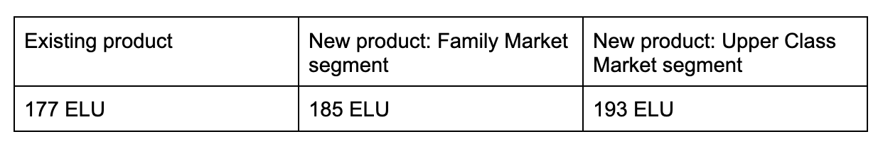

*Figure 5.9*

## 5.3 DFA – New product

The DFA for the new product was done similarly as for the existing product. A total of 16 assembly steps were identified, although it is not conclusive because not all parts were considered. The total DFA score was 87% with an assembly time of 122.8 seconds. See figure 5.10

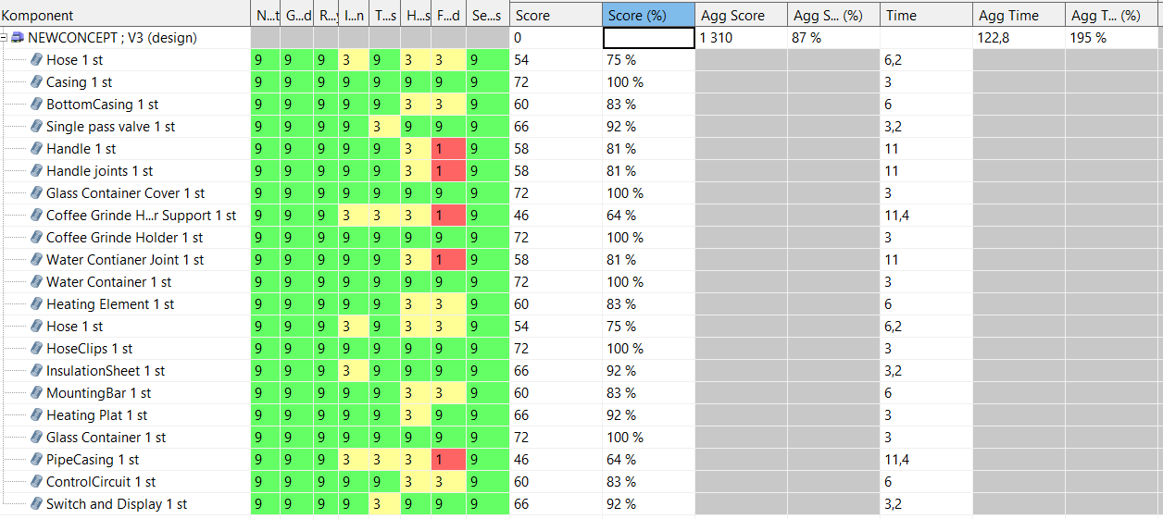

*Figure 5.10 The score taken from AVIX*

## 5.4 FMEA – New product

A similar approach is taken from each function of the coffee machine designed, potential failure modes were identified. Their effects were derived, as well as their potential causes. For these causes, a focus was taken on the components of the machine.

Severity, occurrence and detectability were established, to obtain the RPN. A heat map of the resulting RPN allows for a classification of the failure modes for which actions need to be taken. Actions were then recommended when the RPN values were the highest, but also when severity was above 9.

Complete table can be found in (appendix G).

It can be seen that overall, the most severe failure modes arise from components obtained from suppliers, namely the thermostat and the control card.

* They can fail by themselves, in which case actions to take are to ask the supplier to prove the quality of the products
* It can also happen that they get damaged to the conditions of humidity and heating created during the usage of the coffee machine. When this configuration happens, actions will be things such as checking the characteristics of the materials, and the physical placements of those important components. In other words, since redundancy is not feasable, the action to take will thus be to protect them as much as possible

After consideration of components supplied, it can be noted that materials selected may give rise to safety issues: they may not be food-safe or may degrade with time due to time and environment constraints. In that case, the emphasis is put on the initial selection of materials, where their characteristics must be verified.

## 5.5 Design FMEA – New product

The design FMEA is a method to determine possible design defects and quality problems. Similarly, to the previous FMEA, a scoring system is evaluated, and actions are recommended to the highest RPN scores. The difference between the previous FMEA and the design FMEA is that the design FMEA is more alike a relationship chart. To be able to analyze the flushes, parallelism problems and gaps between the components, the relations between the visible components are documented in the design FMEA (see appendix H).

## 5.6 Manufacturing cost

The manufacturing cost of the two products for the market segments was estimated using the Synthesiser Tool in EduPack. To estimate the cost is not very easy since many of the manufacturing methods were unavailable for some of the parts, so an equivalent process was used instead for those cases. The Synthesiser tool is used to evaluate the cost to produce each part. Some parts, such as electrical circuits and so on could not be evaluated and therefore a cost was assumed instead. All parts had the following parameters in EduPack:

* Batch size: 100 000 Units
* Load factor: 50%
* Overhead rate: 1330 SEK
* Capital write off time: 5 years

Once the part costs were evaluated, they were summarized for each product. The total part cost to produce the product was:

* Part costs for the family segment: 147 kr
* Part costs for the upper-class people segment: 306 kr

However, this does not consider the cost of assembling the product, getting equipment, transportation and so on. To facilitate this, the values were doubled, so the total manufacturing cost came down to:

Total manufacturing cost for the family segment: 294 kr

Total manufacturing cost for the upper-class people segment: 612 kr

With a profit margin around 20% the total cost for the consumer is:

|  |
| --- |
| Family machine selling price:           350 SEK  Upper class machine selling price:  750 SEK |

# Chapter 6: Verification

The new machine comes in two versions, and it is easy to combine parts from different market segments to create more customized machines. In this chapter a checklist between the family version/ upper-class version and their most important requirements will be verified.

## 6.1 Families segment

|  |  |  |
| --- | --- | --- |
| Target requirement | Fulfilled? | Comment |
| Capacity at least 1,2 L | ✔ | The machine has a capacity of 1,5 L. |
| Maximum 2 small pieces. | ✔ | The machine doesn't have any reachable small parts. |
| Maximum selling price 500 SEK | ✔ | This machine will be sold for 350 SEK. |
| Holding the coffee warm at least 20 minutes | - | In this project, the warming time was not discussed because it belongs to the control unit supplier. |
| Heating plate maximum 70 C | **X** | To achieve this target the heating element will be partially isolated to allow only some heat to penetrate the heating element. This feature can be added for additional cost. |
| Less than 175 ELU | **X** | Since the machine becomes bigger the ELU values become higher because it consumes more coffee plus the machine does not have a reusable filter. |
| Removable parts | ✔ | The water container, Coffee grinds holder and coffee pot are removable. |
| Space saver | ✔ | The machine can be easily mounted to the wall and save up to 25 liters of space under it depending on the kitchen gab. |
| Minimized price | ✔ | This parameter was included in material selection in granta software. |

## 6.2 Upper class segment

|  |  |  |
| --- | --- | --- |
| Target requirement | Fulfilled? | Comment |
| Look exclusive/ luxurious | ✔ | The machine is made of premium materials and has curved surfaces. |
| Stable | ✔ | The machine has a relatively big area between its feet. |
| Powerful | ✔ | The machine has the ability to warm up the water quickly because it is equipped with a powerful heating element. |
| Make a cup of coffee in less than 1 minute. | - | This depends on the type of coffee the customers will use. Because even if the user uses a more powerful heating element, the machine still has some time limitation at the brewing process. |
| Environmental Load unit is not of interest | ✔ | The ELU value is mostly generated in the use phase. So even when premium material was chosen for this machine, it does not affect the ELU value that much. Because the high value comes from the coffee itself. |
| Premium material but still food safe | ✔ | The machine would be made of CFRP because it looks luxurious. But since it must be food safe the CFRP has been replaced with stainless steel. |
| Removable parts | ✔ | The water container, Coffee grinds holder and coffee pot are removable. |
| Capacity of 4 cups | ✔ | The capacity of this machine is more than 4 cups. |

# Chapter 7: Conclusion

After using the Otto & Wood methodology of reverse engineering a new coffee maker is developed with respect to modularity and customer requirements. The first market segment (family) needed a safer and space-saving coffee maker. The problem was solved through a comparison between different solutions and a Kesselring matrix to decide which solution is the best with respect to the requirements. The best solution and most suitable one is the mounting bar which makes the coffee maker mounted on the wall. Through this solution, the market segment of the family could save approximately 15 dm^3 in space. Different analyses were applied to attack the product in different areas e.g. functionality, manufacturability, Assemblability, material selection, quality control, good environmental profile, and design. The water container in the new design is separated from the old casing which makes the water container easier to fill, repair, and change. To get a good balance between modularity, assemblability, and reducing the number of parts, the outlet arm is integrated into the top cover which makes the whole coffee container holder support more critical.

Another area that was improved in the new concept is the material selection. A more conductive material, aluminum, was selected to improve the quality and make it faster because the requirements had a limit of 2-4 minutes of boiling time. In addition, a stiffer material was chosen to make the casing and handle more resistant to bending. The design of the pipe casing is compact and protects the pipes to not let the heat escape and to fulfill the requirements about not making the heated water touchable for the user to make it safer.

For the second market segment, which is the pretentious people, almost the same design was adapted from the first segment, but the mounting bar is removed because the segment does not care much about space like the family segment. The design is almost the same but the materials the coffee maker is made of are totally different. For example, the casing is made of carbon fiber and the handle of brass powder and epoxy.

For future improvements the design could be even more compact and the solution for the mounting bar could be different, there are probably many ways to mount the coffee maker on the wall. Another important factor to take into consideration is a reusable filter with the machine because this can decrease the environmental impacts. But the main point is that this design idea could be adapted or mixed with other designs easily and that’s because our design is modular.

# Chapter 8: Methodology

The methodology for this project is the Otto & Wood methodology of reverse engineering. This method provides data and analysis, not only for the new product, but also for the existing product that will be redesigned. In addition, this method saves much time because it does not start from scratch and has a very structured way to follow. The disadvantage of the Otto & Wood method is that its easy to fall into legal problems if the redesigned product is very likely the same of the competitors. The main idea with the methodology is to improve an existing product instead of designing a new one, which benefits the company with lower costs. A very good aspect of this method is that when analyzing an already existing product, and disassemble it, sparks to innovation and discovery. These discoveries could reveal weaknesses, which makes it easier for the engineers to overcome and fix. A weakness is a common problem that could lead to damages, not only to the product itself, but may also to user. Because of this methodology, these weaknesses could be fixed if it combines with the requirements of the targeted segment, for example, our market segment wants a coffee machine that is not reachable for their kids, but also wants to save space, therefore a wall mounted coffee machine would solve these two problems. As mentioned, an already existing product could save much time and reduce costs, but this does not mean that this method is perfect. The main problem with this method is that it depends on someone else’s work, and this could be seen as an ethical problem. Because this method, as mentioned, studies an existing product, and tries to improve it and change it a little bit. This means that the company with the original design did pay more for the product design because they do much more research, interviews, and studies of the targeted segments. While the re-designer saves money, the original designer will have to sell the original product for higher price and that is a consequence of these difficulties for the original design, which creates a new problem with the competitors.

# ***Appendices***

***Note:*** If it is difficult to read the sheets below. You can find the original sheets at their path in the folder “*Group-1-Project-MMF092*”.

## Appendix A: Bill of material for existing product

Sheet path: “*Group-1-Project-MMF092/ BOM_Existing_Product*”

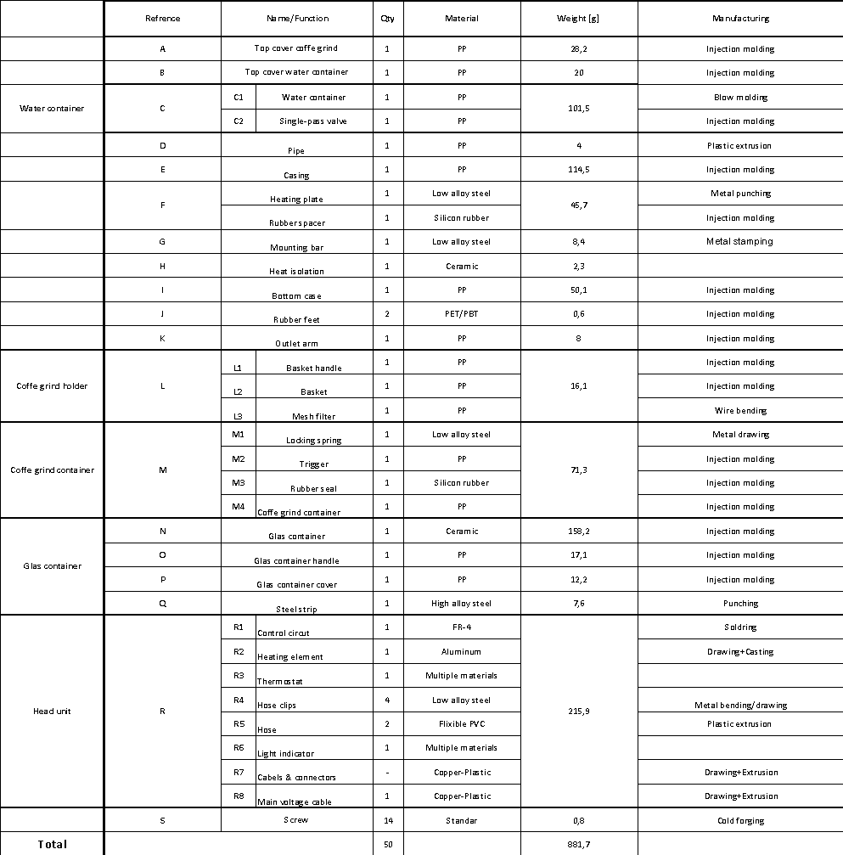

## Appendix B: Requirement specification for existing product

Sheet path: “*Group-1-Project-MMF092/Requirement Specification/Requirement Specification*”

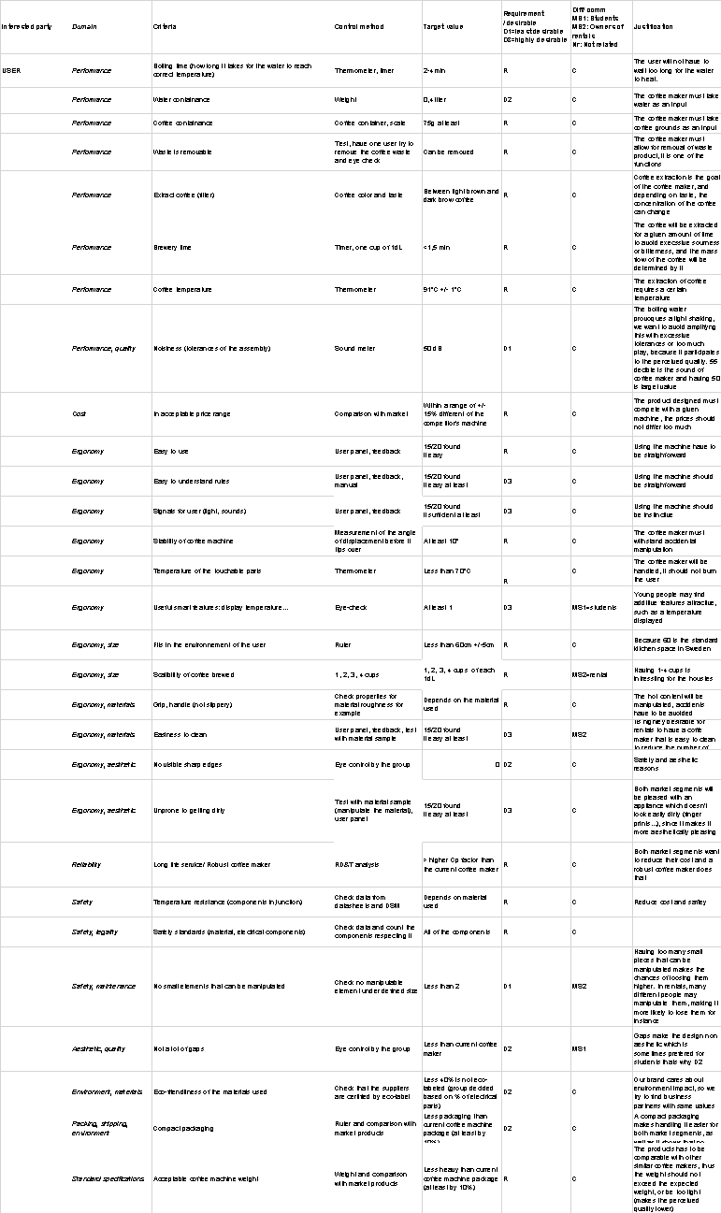

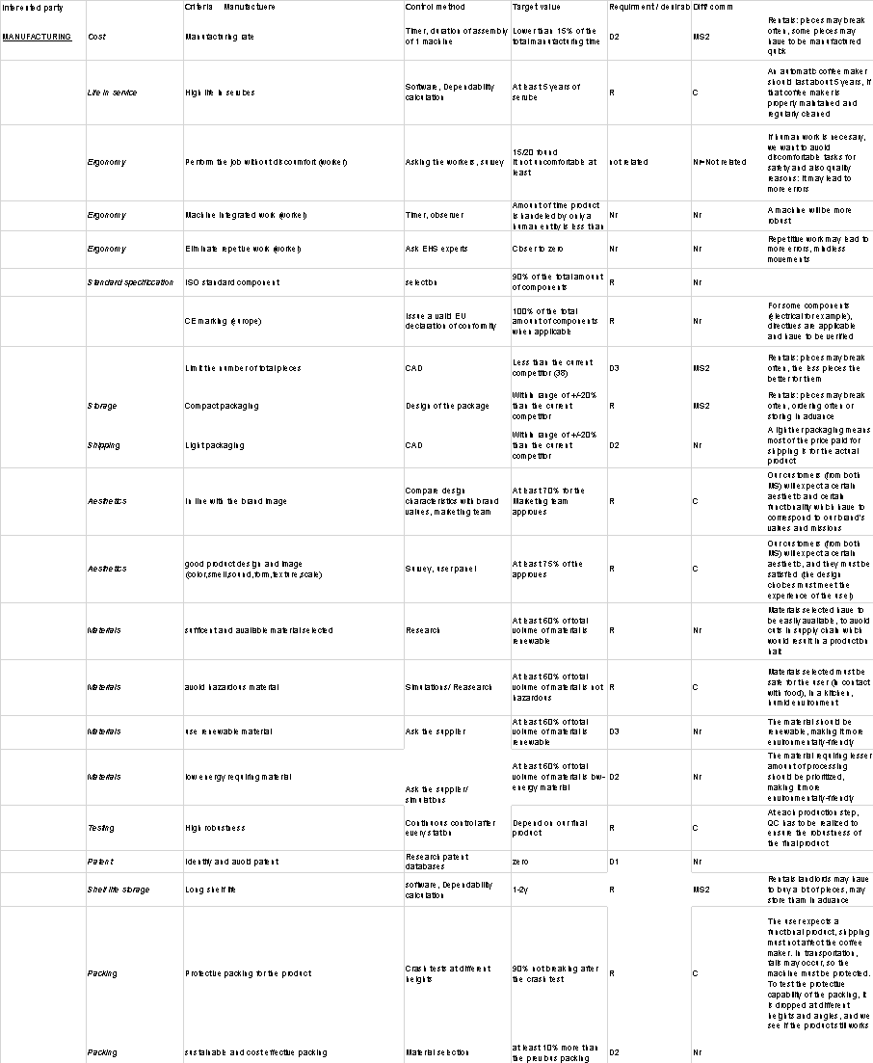

## Appendix C: LCA – Existing product

Sheet path: “*Group-1-Project-MMF092/* *LCA-Existing-and-New-Product /* *Existing product*”

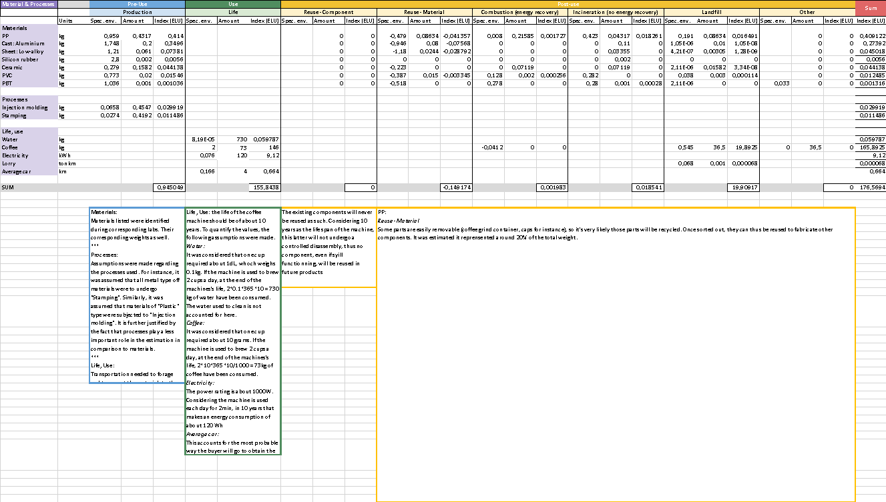

## Appendix D: Requirement specification for both market segments

The pictures of the appendix D were removed because they were absolutely nonreadable.

You can find the appendix at:

Sheet path: “*Group-1-Project-MMF092/Requirement Specification/* *Specific to Families*”

Sheet path: “*Group-1-Project-MMF092/Requirement Specification/* *Specific to Upper class*”

## Appendix E: Morphologic matrix

Sheet path: “*Group-1-Project-MMF092/* *Morphological matrix*”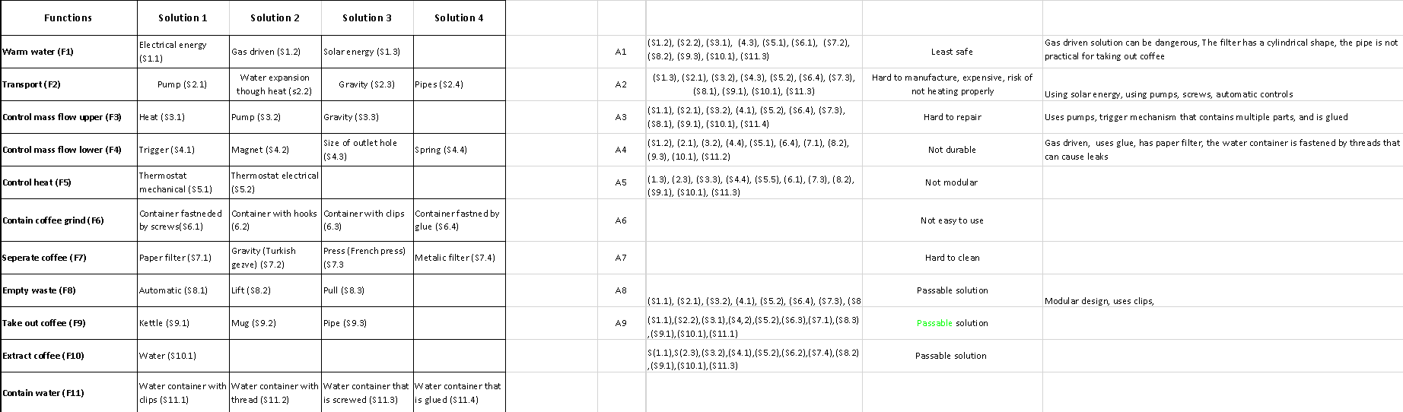

## Appendix F: Kesselring matrix

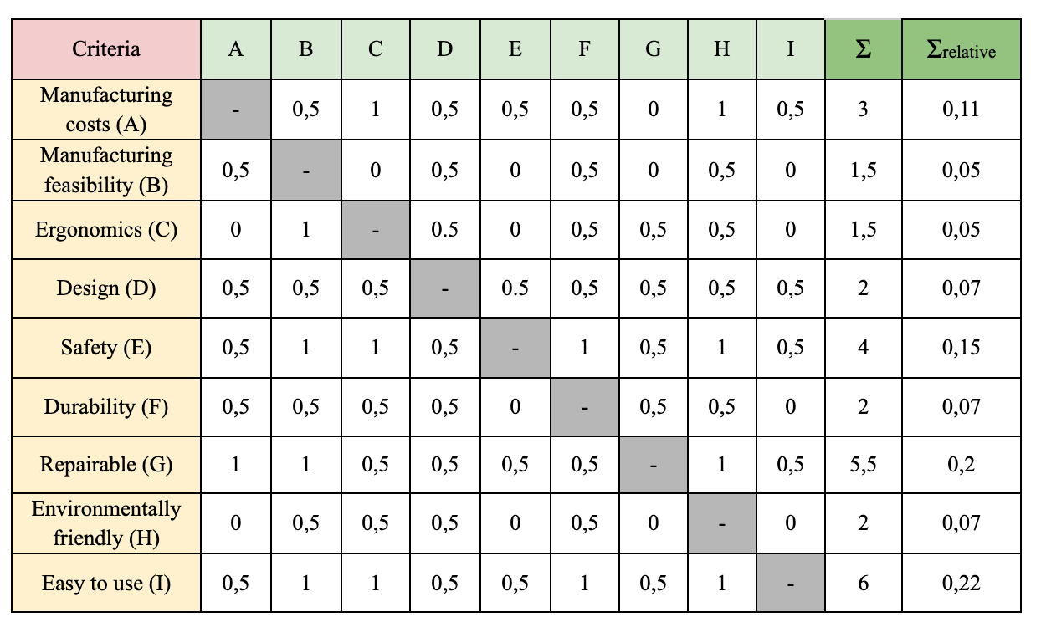

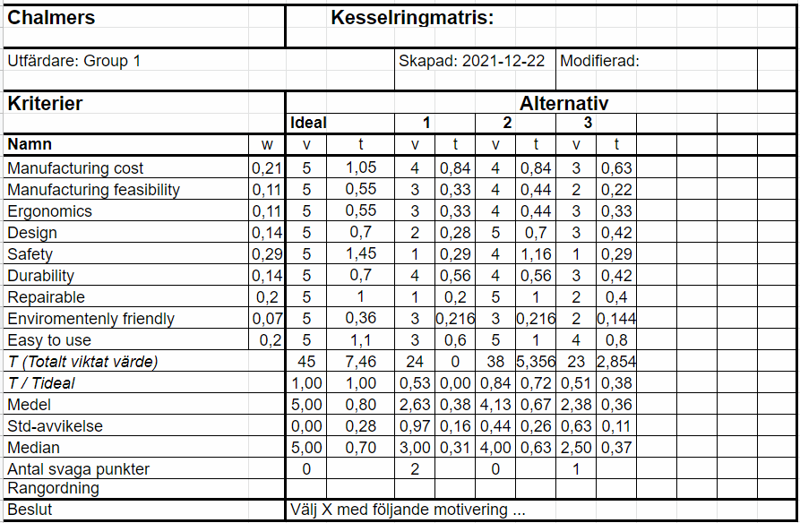

## Appendix G: FMEA – New product

The pictures of the appendix G were removed because they were absolutely nonreadable.

You can find the appendix at:

Sheet path: “*Group-1-Project-MMF092/FMEA-New Product/FMEA*” (for existing product)

Sheet path: “*Group-1-Project-MMF092/FMEA-New Product/New FMEA*” (for new product)

Sheet path: “*Group-1-Project-MMF092/FMEA-New Product/Blad4*” (for new products, but only the failure modes for which actions were proposed)

## Appendix H: Design FMEA – New product

Sheet path: “*Group-1-Project-MMF092/Design FMEA- New Product*”

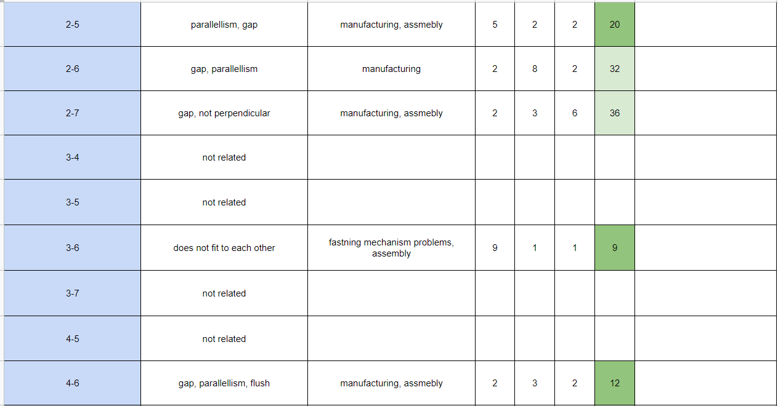

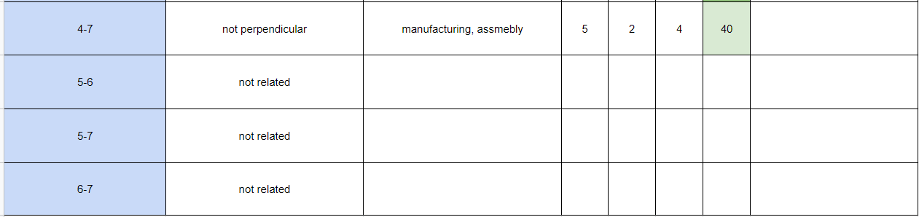

## Appendix I: BILL of material for the new product

Sheet path: “*Group-1-Project-MMF092/BOM-new-product*”

## Appendix J: LCA New Product

Sheet path: “*Group-1-Project-MMF092/* *LCA-Existing-and-New-Product/Family*”

Sheet path: “*Group-1-Project-MMF092/* *LCA-Existing-and-New-Product /*Upper class”